AWX-Management Setup

Contents

1. Git Project Setup 3

1.1 AWX-Management Project 3

1.2 Ruckus-ICX-AWX-Ansible Project 5

1.3 AWX-ZTP Project 6

1.4 Manual Project Setup 7

2. Credential Setup 9

2.1 Switch Login Credentials 9

2.2 AWX Login Credentials 11

2.2.1 Create Custom Credential Type 11

2.2.2 Add AWX Login Credentials 13

2.3 AWX SSH Login Credentials 14

3. Inventory Setup 15

3.1 Switch Inventory 15

3.2 Switch Host 16

3.3 AWX Server Inventory 17

3.4 AWX Server Host 18

4. Setup AWX-Management Template 19

4.1 AWX-Template-Management Template 19

4.2 Generate AWX-Template-Management Survey Prompt 21

5. Generating New Templates 22

5.1 Ruckus-ICX-AWX-Ansible Templates 22

5.2 View Templates 23

6. Updating Playbooks and Templates 25

6.1 Manual update of project playbooks 25

6.2 Automated update of project playbooks 26

6.3 Automated update of project templates 28

7. Custom Template Creation 30

8. Image Management 32

8.1 Image Repository Creation 32

8.2 Import images to AWX server 33

8.2.1 (Method 1) TFTP pull from AWX server 33

8.2.2 (Method 2) SCP push to AWX server. 37

8.3 View Image Repository Files 40

8.4 Copy image files to switch flash 42

8.4.1 Switch image copy (using Pexpect module) 42

8.4.2 Switch image copy (using icx_copy module) 45

9. Setup AWX-ZTP 48

9.1 Create 'ZTP-Install' Template 49

9.2 Launch "ZTP-Install" 50

9.3 Launch "ZTP-Configure" 54

9.4 Workflow Creation 58

9.5 Adding Workflow to ZTP 71

# 1. Git Project Setup

## 1.1 AWX-Management Project

To add the AWX-Management playbooks to a project, first click on the **Projects** menu on the left, then click the **+** button:

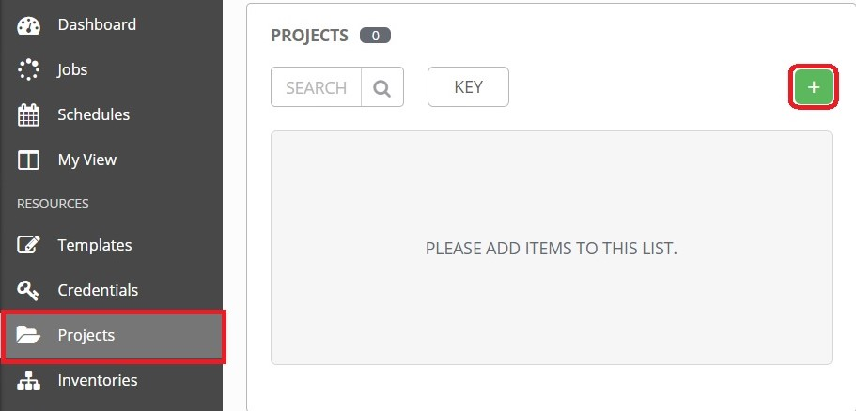

This opens the **New Project** page:

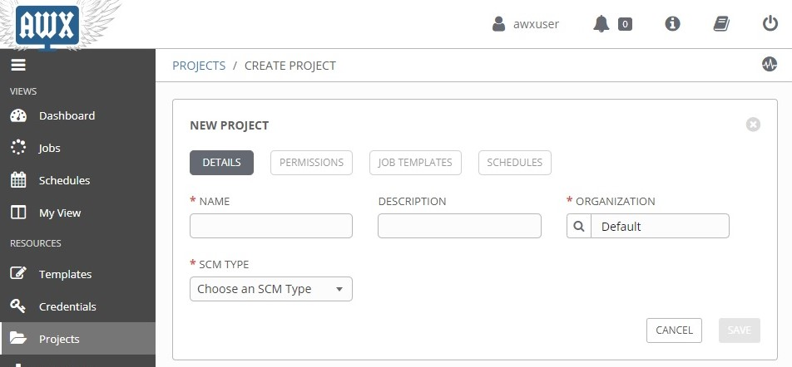

Enter the following into the required fields:

**NAME:** Name the project "*AWX-Management*"

**SCM TYPE:** Select "*Git*"

**SCM URL:** Type in "*https://github.com/steppb/AWX-Management*".

**Organization:** A project must have at least one organization. Here, "*Default*" is selected.

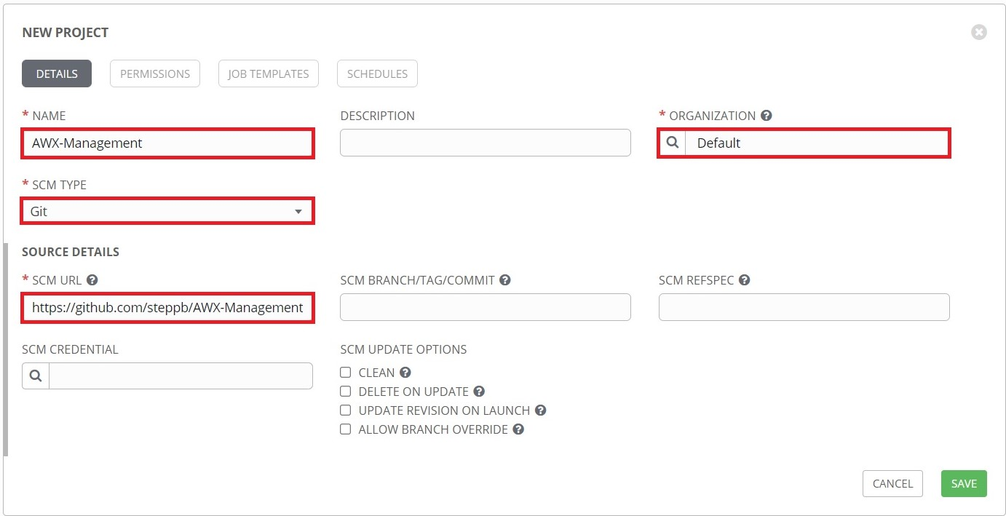

When you are finished, click **Save**.

At this point **AWX-Management** will be added to the list of projects and it will begin syncing with the Github repo. An animated green circle next to the project indicates the project is currently syncing. A static green circle indicates the project has successfully finished syncing and the playbooks are ready for use:

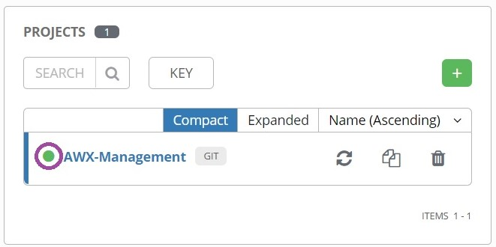

A red circle would indicate a failure during syncing. You can click on the circle to bring up a status window showing the details of the syncing process.

## 1.2 Ruckus-ICX-AWX-Ansible Project

To add the "Ruckus-ICX-AWX-Ansible" playbooks to a project, first click the **Projects** menu on the left, then click the **+** button:

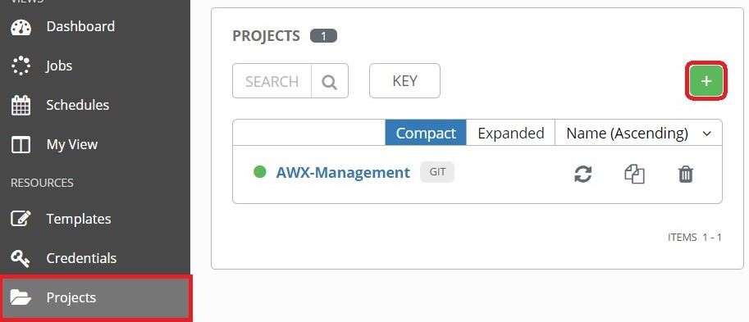

This opens the **New Project** page. Enter the following into the required fields:

**Name:** Enter the name of the project. Here, it is named "*Ruckus-ICX-AWX-Ansible"*.

**SCM Type:**  Select "*Git*".

**SCM URL:** Enter "*https://github.com/steppb/Ruckus-ICX-AWX-Ansible".*

**Organization:** A project must have at least one organization. Here, "*Default*" is selected.

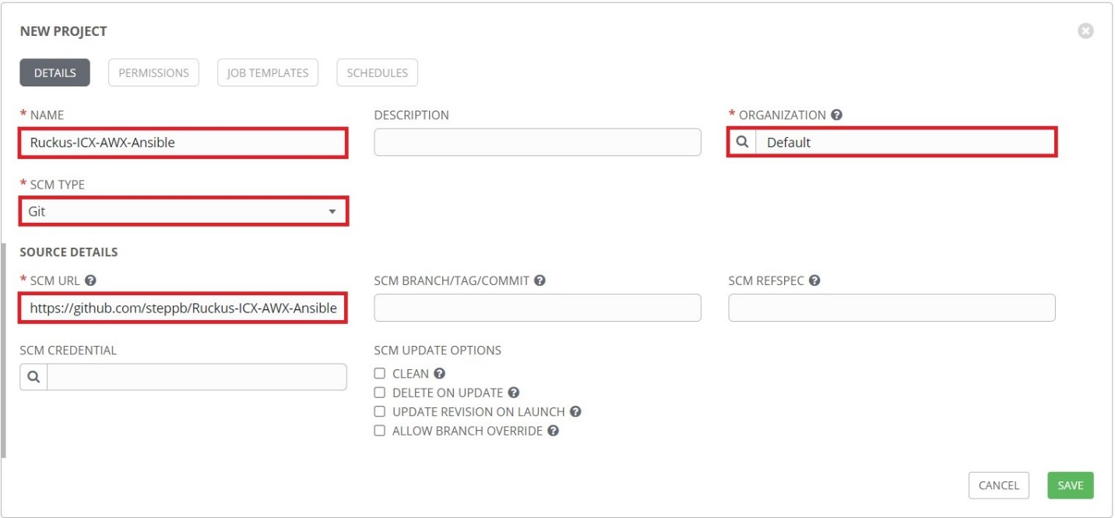

When you are finished, click **Save**.

## 1.3 AWX-ZTP Project

To setup the AWX-ZTP project, first click **Projects** from the left navigation bar, then click the **+** button. Complete the following fields on the **New Project** page:

**NAME:** Name the project "*AWX-ZTP*"

**ORGANIZATION:** Ensure an organization is selected.

**SCM TYPE:** Select **Git**.

**SCM URL:** Enter "*https://github.com/steppb/AWX-ZTP*".

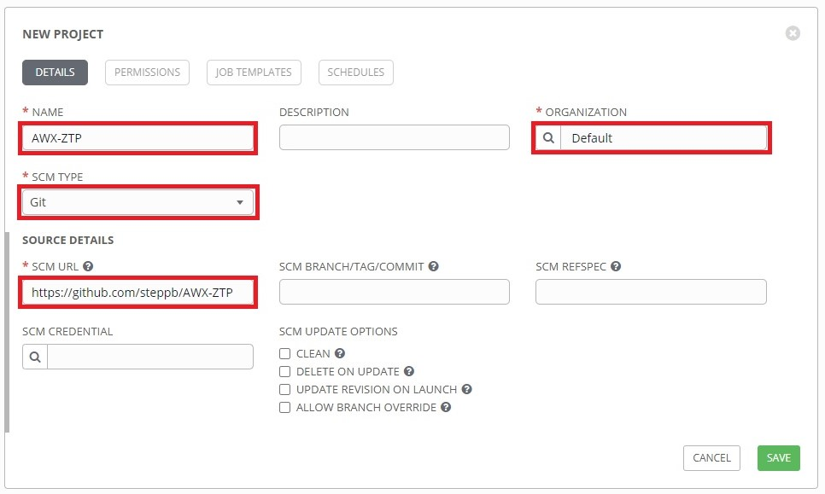

Click **Save**, when finished.

## 1.4 Manual Project Setup

If the AWX server is located on a closed network that does not have internet access, the projects will need to be manually created. The following provides a step-by-step guide to setup the AWX-Management project manually.

The first step is to get the downloaded AWX-Management playbooks onto the AWX server. This can be done with some form of removable media.

Once the playbooks are on the AWX server, launch an SSH session to the AWX server and use the following commands to create a project directory and copy the files to that directory. The following commands assume the playbooks have been copied to ~/Documents/AWX-Management:

|  |
| --- |
| sudo mkdir /var/lib/awx/projects/AWX-Management  sudo cp -R ~/Documents/AWX-Management /var/lib/awx/projects/AWX-Management/ |

After the playbooks have been copied to the AWX project directory, the project can then be created in AWX. From the AWX web GUI, click **Projects** from the left navigation bar, then click the **+** button:



This opens the **New Project** page:



Enter the following into the required fields:

**NAME:** Name the project "*AWX-Management*"

**SCM TYPE:** Select "*Manual*"

**PLAYBOOK DIRECTORY:** Select "*AWX-Management*"

**ORGANIZATION:** A project must have at least one organization. Here, "*Default*" is selected.

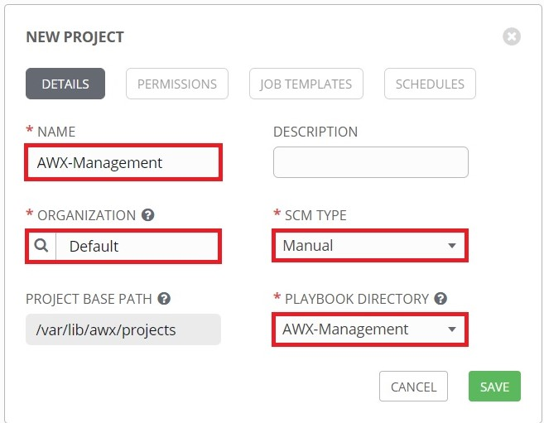

Click **Save**, when finished.

Repeat the steps to set up the '*Ruckus-ICX-AWX-Ansible*' project.

Note: The install playbooks in the '*AWX-ZTP*' project will not be able to install the required components on a closed network.

# 2. Credential Setup

## 2.1 Switch Login Credentials

Click on the **Credentials** menu on the left, then click the **+** button:

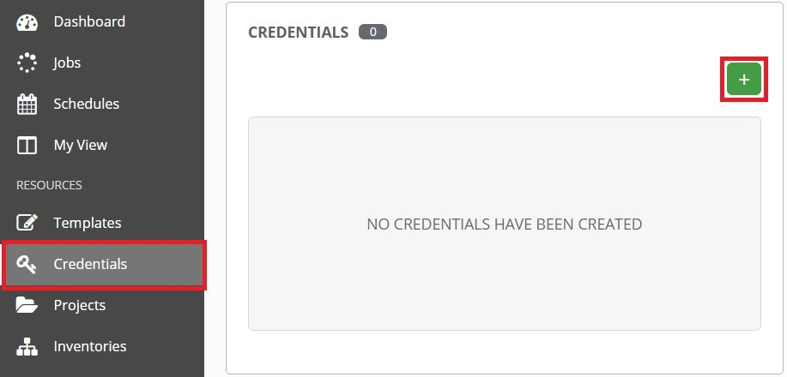

The **New Credential** page will display. Complete the following fields:

**NAME**: Create a name for the credential set. Here it is named "*ICX Login*"

**CREDENTIAL TYPE:** Select **Machine**.

**USERNAME** & **PASSWORD:** Enter the username and password used to login to the switch.

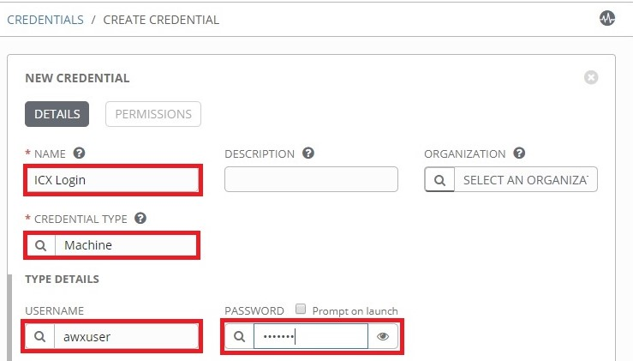

Scroll to the bottom of the **New Credential** page. Here you can set the enable username and/or password:

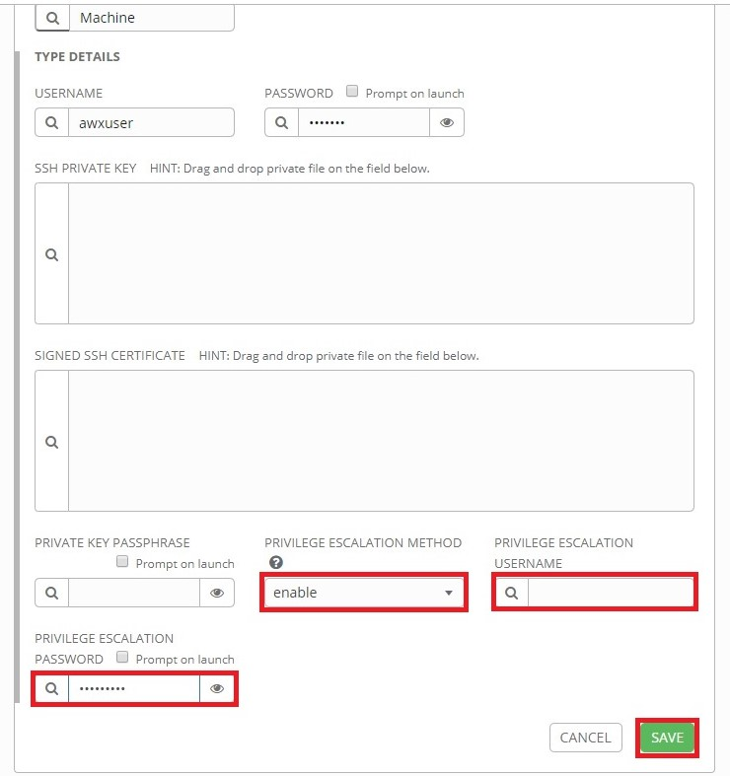

When finished, click **Save**.

## 2.2 AWX Login Credentials

The "AWX-Management" playbooks contain variables that need to be defined with credentials for logging into the AWX REST API framework. In order to accomplish this, a custom credential type will need to be created.

### 2.2.1 Create Custom Credential Type

First, click the **Credential Types** menu on the left, then click the **+** button:

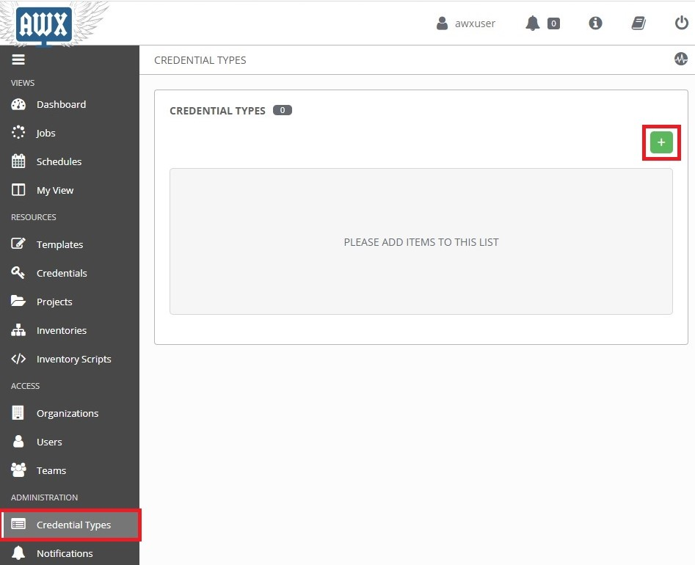

This opens the **New Credential Type** page.

Enter the following into the required fields:

**NAME:** Enter the name of the credential type. Here, it is named "*AWX REST API*"

**DESCRIPTION:** (Optional) Enter a description.

**INPUT CONFIGURATION:** Ensure **YAML** is selected. Then copy and paste the following into the box:

|  |
| --- |
| fields:  - id: username  type: string  label: AWX Username  - id: password  type: string  label: AWX Password  secret: true  required:  - username  - password |

**INJECTOR CONFIGURATION:** Ensure **YAML** is selected. Then copy and paste the following into the box.

|  |
| --- |
| extra_vars:  awxlogin_user: '{{username}}'  awxlogin_pass: '{{password}}' |

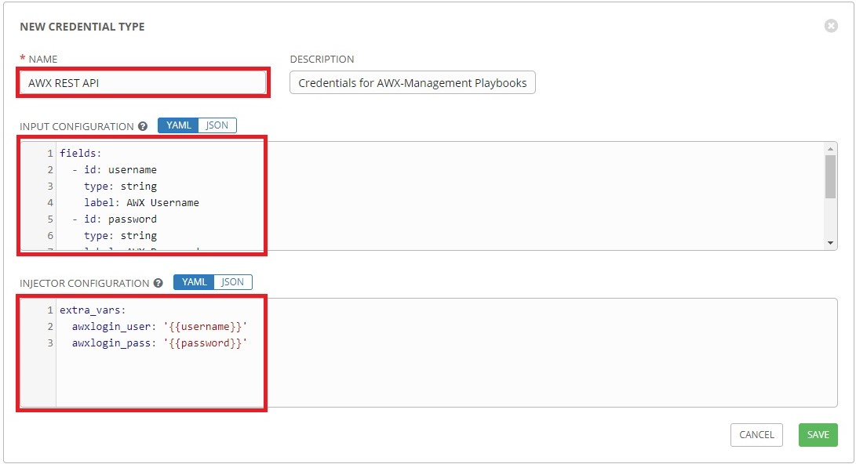

When you are finished, click **Save**.

Now that the custom credential type has been set up, a credential set for the AWX-Management playbooks can be created.

### 2.2.2 Add AWX Login Credentials

Click on the **Credentials** menu on the left, then click the **+** button:

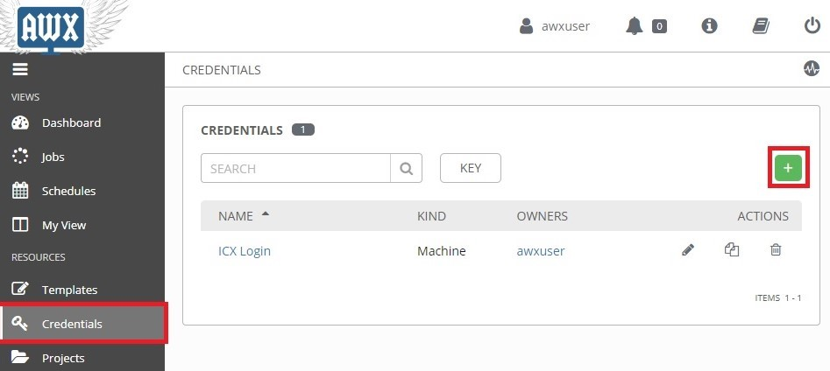

This opens the **New Credential** page.

Enter the following into the required fields:

**NAME:** Name of the credential set. Here it is named "*AWX Login*"

**CREDENTIAL TYPE:** Select the custom credential type. Here it is named "*AWX REST API*"

**AWX USERNAME** & **AWX PASSWORD:** Type in the credentials used to login to AWX.

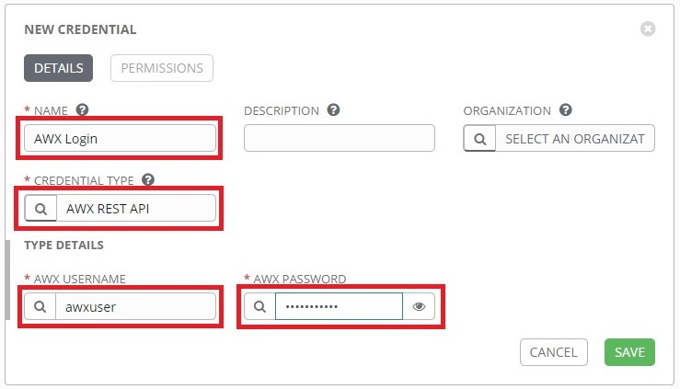

When you are finished, click **Save**.

## 2.3 AWX SSH Login Credentials

Some of the playbooks in the 'AWX-Management' and 'AWX-ZTP' projects require SSH credentials to connect to the Docker container host. To run these playbooks a new credential set will need to be added with the SSH credentials for the AWX server.

To add the localhost SSH credentials, click **Credentials** from the left navigation bar, then click the **+** button. Complete the following fields on the **New Credential** page:

**NAME:** Type a name for the credential set.

**CREDENTIAL TYPE:** Select **Machine**.

**USERNAME** & **PASSWORD:** Type in the username and password used to SSH into the AWX server.

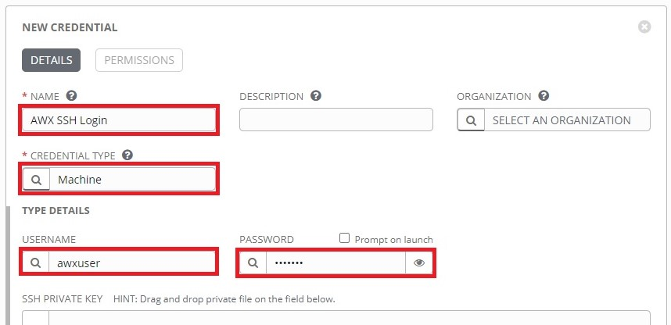

Scroll to the bottom and complete the following fields:

**PRIVILEGE ESCALATION METHOD:** Select **sudo**.

**PRIVILEGE ESCALATION PASSWORD:** Type in the **sudo** password.

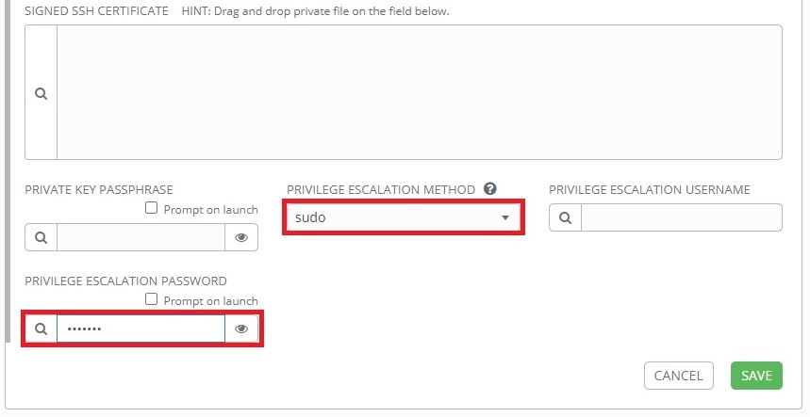

Click **Save** when finished.

# 3. Inventory Setup

## 3.1 Switch Inventory

An inventory for network devices will need to be setup before AWX can manage them.

Click the **Inventories** button from the left navigation bar. Click the **+** button, then click **Inventory** from the drop-down menu:

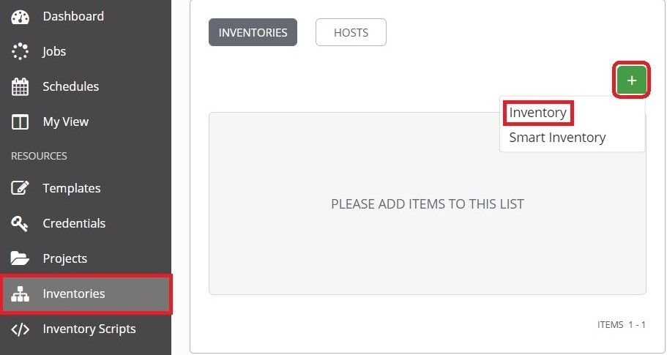

This opens the **New Inventory** page.

Complete the following fields:

**NAME:** Enter a name for the Inventory. Here the inventory is named "*Ruckus Switches*".

**Organization:** Select the organization the inventory belongs to. Here "*Default*" is selected.

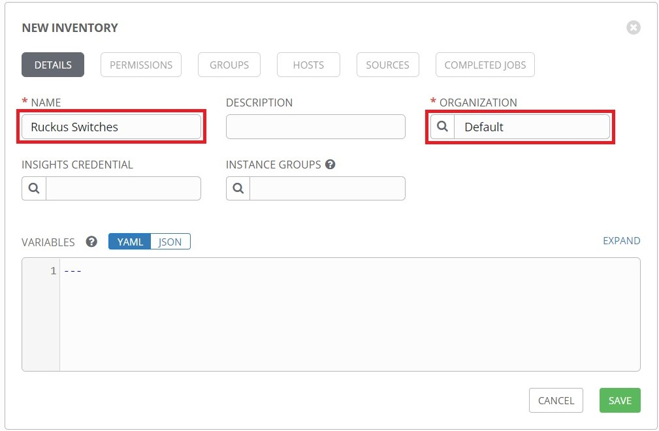

When you are finished, click the **Save** button.

## 3.2 Switch Host

Switches can now be added to the newly created inventory.

Click on the **Hosts** tab, then click the **+** button:

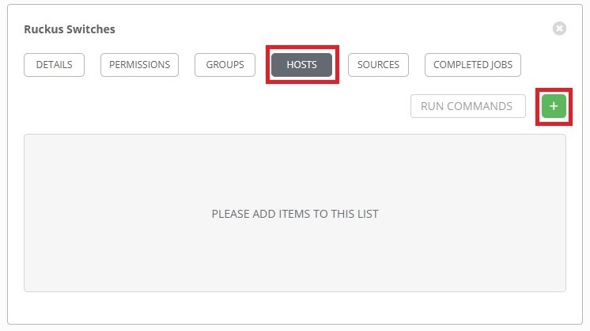

The **Create Host** page will display. Complete the following fields:

**HOST NAME:** Enter the hostname of the switch.

**VARIABLES:** Type "**ansible_host:** " followed by the IP address of the switch.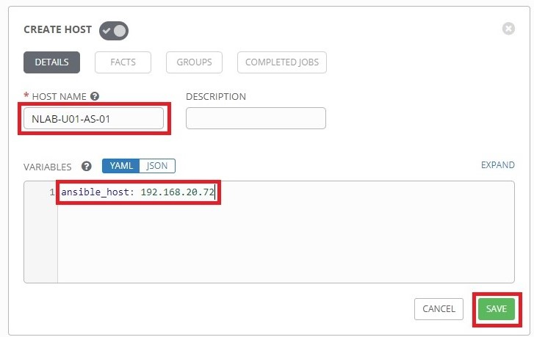

When finished, click **Save.**

## 3.3 AWX Server Inventory

An inventory for the AWX Server itself will need to be setup in order to execute the AWX-Management templates against itself.

Click the **Inventories** button from the left navigation bar. Click the **+** button, then click **Inventory** from the drop-down menu:

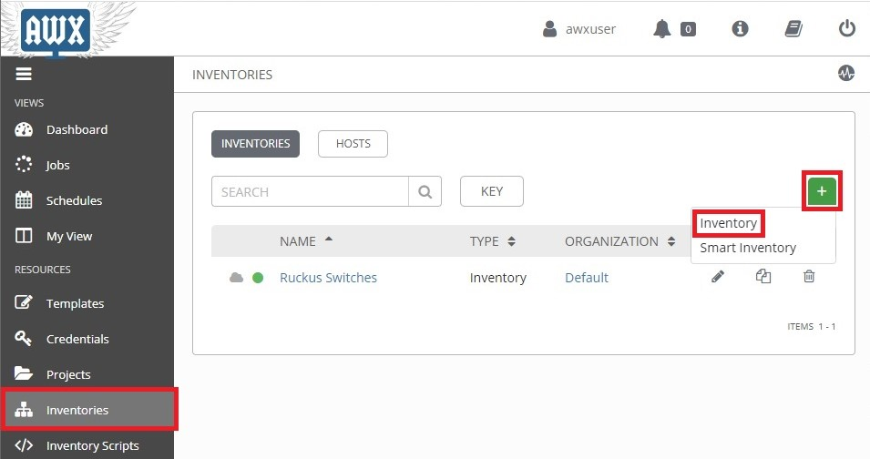

This opens the **New Inventory** page.

Complete the following fields:

**NAME:** Enter a name for the Inventory. Here the inventory is named "*AWX Server*".

**Organization:** Select the organization the inventory belongs to. Here "*Default*" is selected.

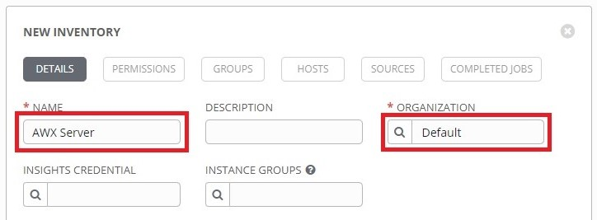

When you are finished, click the **Save** button.

## 3.4 AWX Server Host

Click the **Hosts** tab, then click the **+** button:

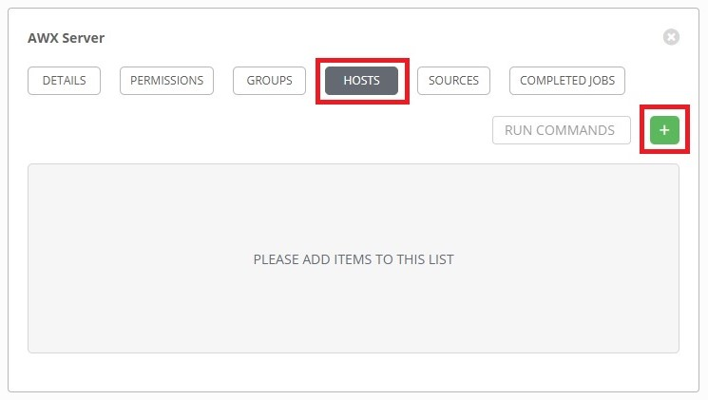

This opens the **Create Host** page.

Complete the following fields:

**HOST NAME:** Enter the hostname of the AWX server. Here it is called "*awxserver*".

**VARIABLES:** Type in "*ansible_host:* " followed by the IP address of the AWX server.

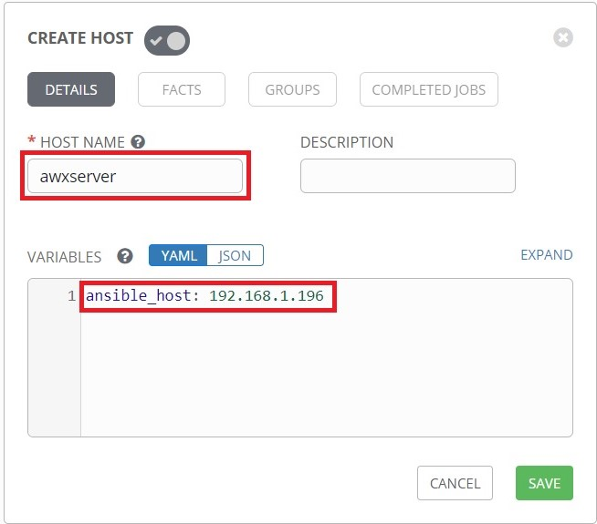

Click **Save** when done, and the AWX server will be added to the Inventory's list of hosts.

# 4. Setup AWX-Management Template

## 4.1 AWX-Template-Management Template

Click the **Templates** button from the left navigation bar. Click the **+** button, then click **Job Template** from the drop-down menu:

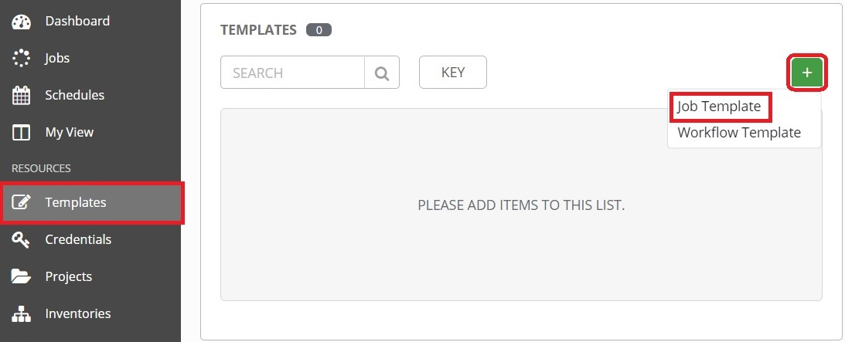

This opens the **New Job Template** page.

Complete the following fields:

**NAME:** Enter a name for the template. Here it is named "*AWX-Template-Management*"

**DESCRIPTION:** (Optional) Enter a description of the template.

**JOB TYPE:** Select **Run**.

**INVENTORY:** Select the inventory that contains the AWX server. Here it is "*AWX Server*"

**PROJECT:** Select **AWX-Management**.

**PLAYBOOK:** Select **AWX-Template-Management.yml**.

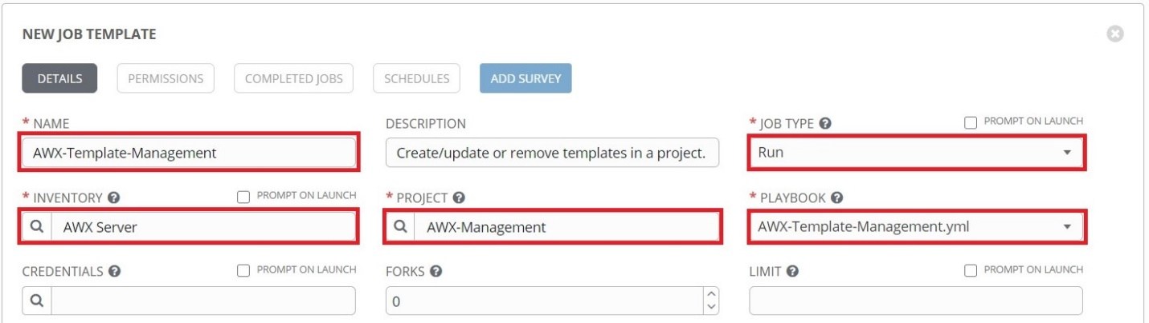

**CREDENTIALS:** Click the  button to open the credentials window. Select the custom credential type in the **Credential Type** drop-down menu, then select the AWX Login credentials:

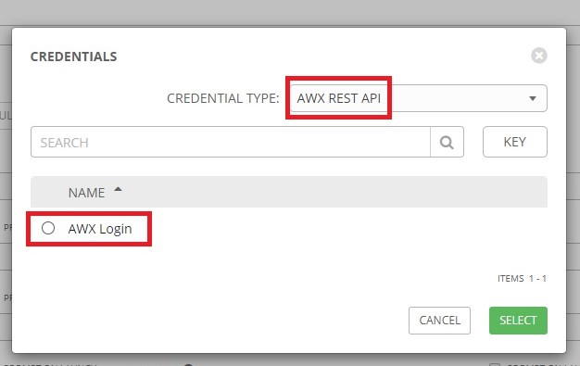

Click **Select** when done, then click **Save** to save the template.

## 4.2 Generate AWX-Template-Management Survey Prompt

Click the **Templates** button from the left navigation bar. Then click the launch () button next to **AWX-Template-Management**:

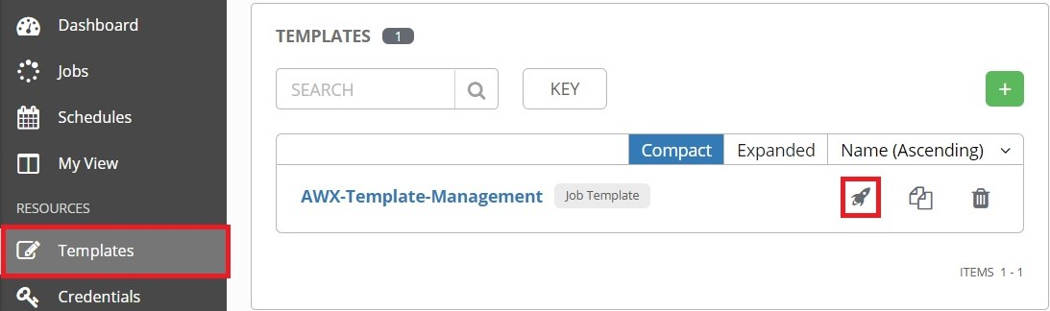

Upon completion, the "*AWX-Template-Management*" template automatically generates a survey prompt for itself and it will also create the "*Image-Management*" template before ending the play.

# 5. Generating New Templates

## 5.1 Ruckus-ICX-AWX-Ansible Templates

Click the **Templates** button from the left navigation bar. Then click the launch () button next to **AWX-Template-Management**:

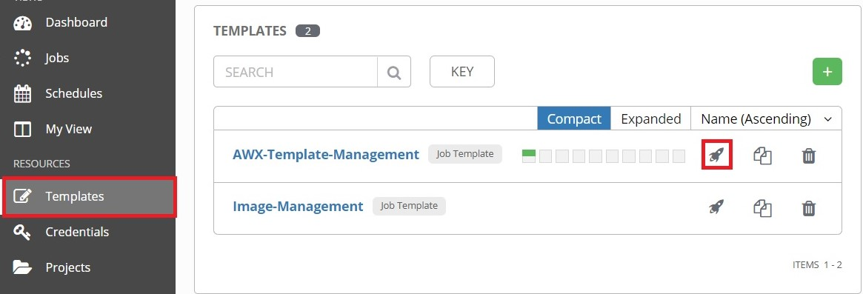

Complete the following fields in the Survey Prompt window that appears:

**TEMPLATE MANAGEMENT FUNCTION:** Select **Create/Update Templates**.

**PROJECT:** Select **Ruckus-ICX-AWX-Ansible**.

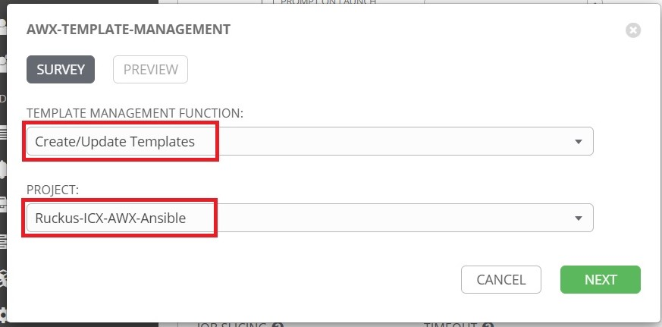

Click **Next** when finished, then click **Launch** on the Preview tab to run the template.

## 5.2 View Templates

To view the new templates, first click the **Projects** button from the left navigation bar, then click **Ruckus-ICX-AWX-Ansible**:

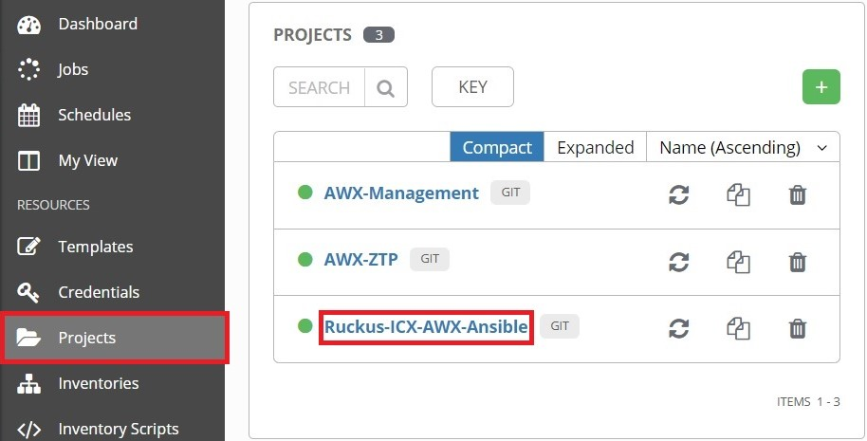

Click the **Job Templates** tab:

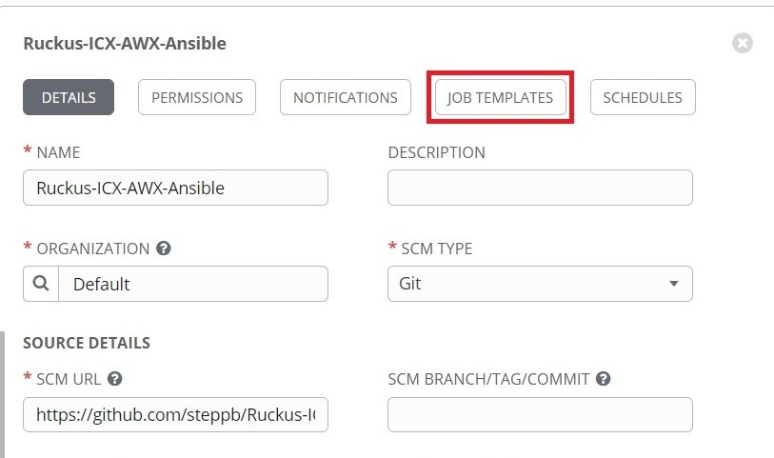

The new templates should now be visible in this tab:

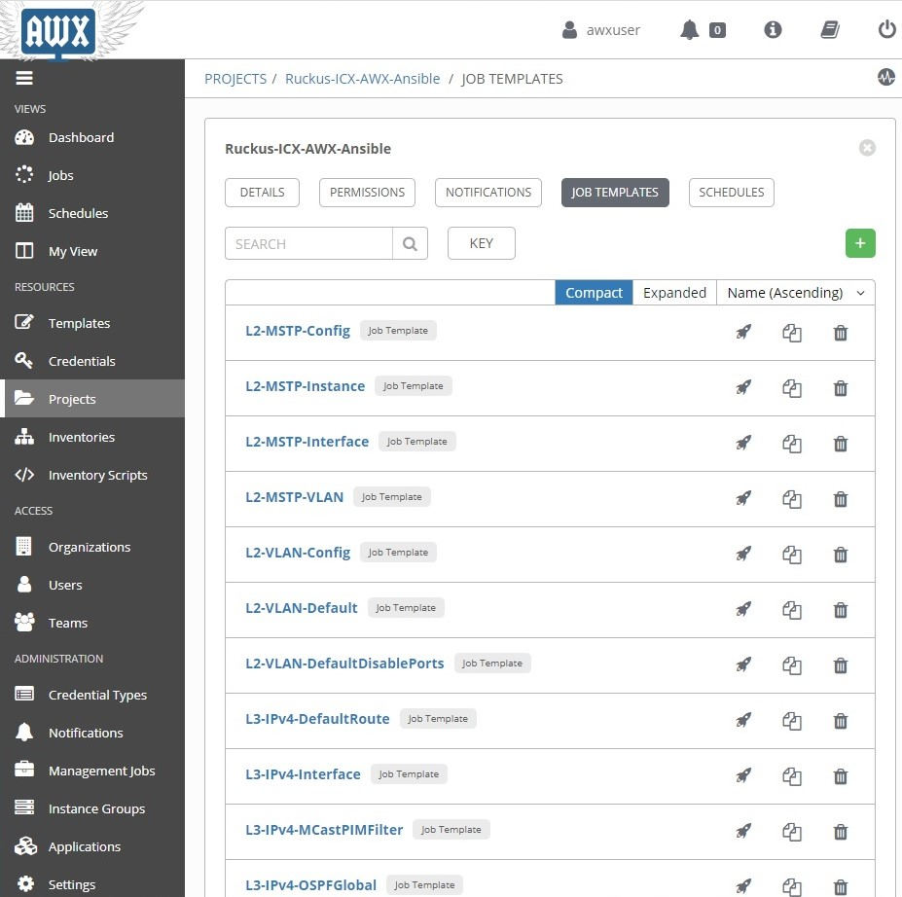

# 6. Updating Playbooks and Templates

Git projects by default do not update local playbooks when changes occur upstream. The following section covers manual and automated methods of updating the templates and playbooks in a project.

## 6.1 Manual update of project playbooks

Click the **Projects** button from the left navigation window, then click the refresh () button for the **Git** projects to sync playbooks with the upstream repository:

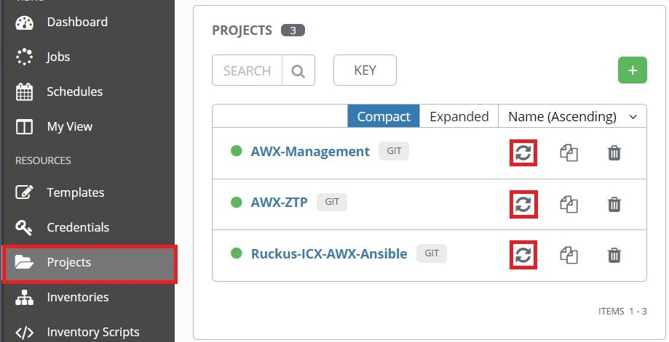

Project templates can be updated by rerunning the "*AWX-Template-Management*" template from the instructions in the "*Generating New Templates*" section above.

## 6.2 Automated update of project playbooks

The following will run through a schedule-based method to update both the playbooks and templates.

Click the **Projects** button from the left navigation menu. Then click the "*Ruckus-ICX-AWX-Ansible*" project:



Click the **Schedules** tab, then click the **+** button:

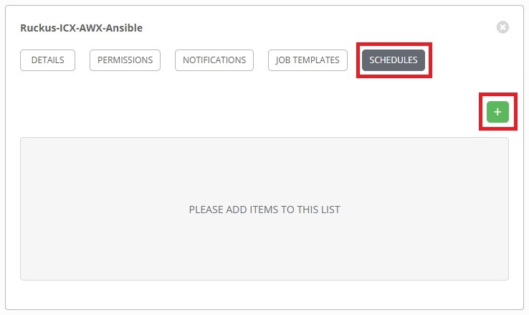

This will open the **Create Schedule** page. Complete the following fields:

**NAME:** Name of the schedule.

**START DATE:** First day the schedule takes effect.

**START TIME:** Time of first run (24-Hour Clock format).

**LOCAL TIME ZONE:** Time zone local to AWX Server.

**REPEAT FREQUENCY:** How often the sync will occur.

The following is an example of a sync that will occur daily at 11:00PM ET starting 6/19/2020:

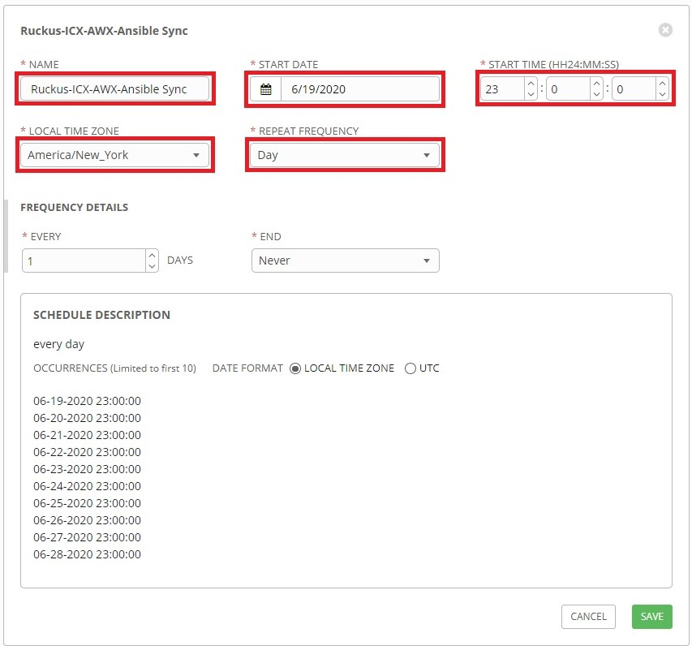

When finished, click **Save**.

If desired, automating the update of other **Git** projects can be set up using the instruction above.

## 6.3 Automated update of project templates

Note: The *"AWX-Template-Management"* will automatically pull playbook updates from the Git server before updating the AWX templates.

Click the **Templates** button from the left navigation bar, then click "*AWX-Template-Management*":

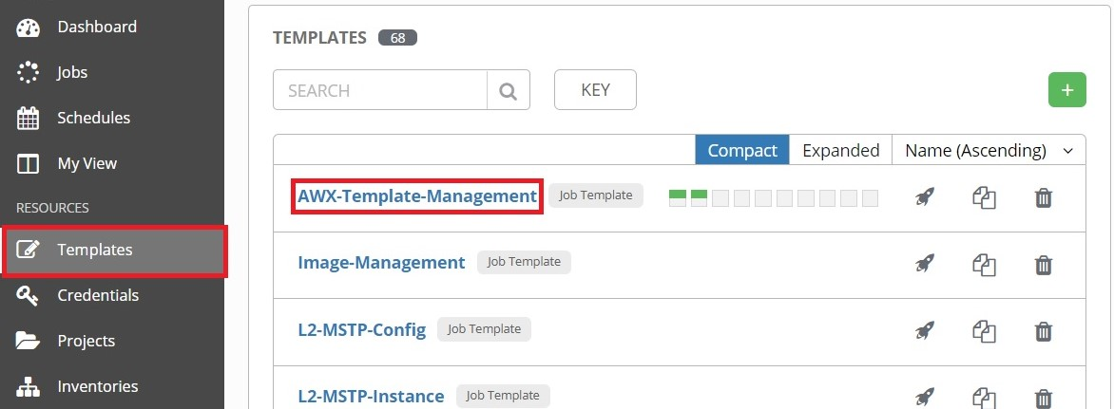

Click the **Schedules** tab, then click the **+** button:

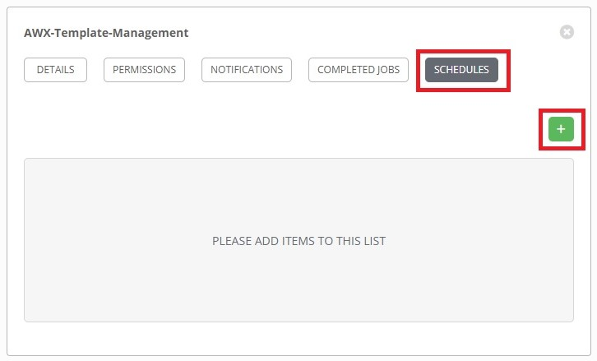

This will open the **Create Schedule** page. Complete the following fields:

**NAME:** Name of the schedule.

**START DATE:** First day the schedule takes effect.

**START TIME:** Time of first run (24-Hour Clock format).

**LOCAL TIME ZONE:** Time zone local to AWX Server.

**REPEAT FREQUENCY:** How often the sync will occur.

The following is an example of a sync that will occur daily at 11:35PM ET starting 6/19/2020:

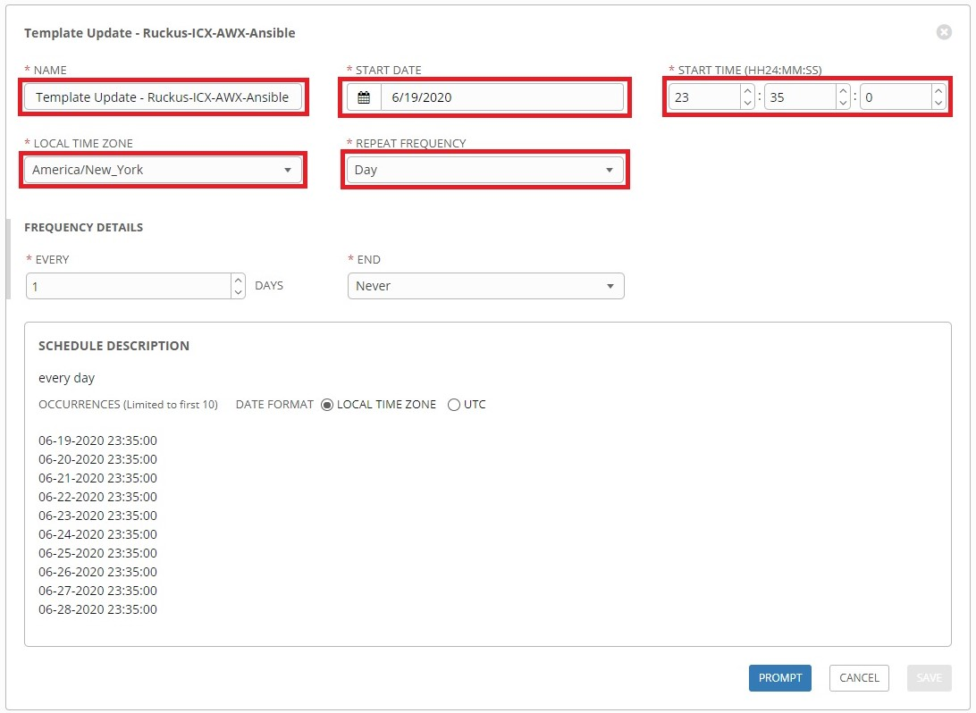

When finished, click the **Prompt** button to open the prompt window.

Complete the following fields on the Survey prompt:

**TEMPLATE MANAGEMENT FUNCTION**: Select **Create/Update Templates**.

**PROJECT**: Select **Ruckus-ICX-AWX-Ansible**.

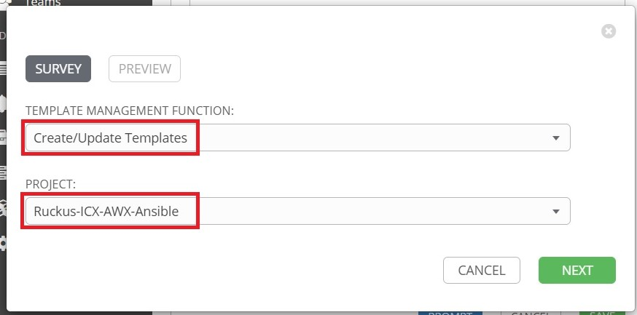

Click **Save** when finished, then click **Confirm** on the next tab to schedule the template to run.

# 7. Custom Template Creation

The 'Ruckus-ICX-AWX-Ansible' project contains a playbook named 'ICX-Custom-Config.yml'. The 'AWX-Template-Management' template does not create a template for this playbook. This playbook can be used to create custom configuration templates. The following provides an example of how to create a custom configuration template.

Click the **+** button on the **Templates** page then click **Job Template** to open the **New Job Template** page. Complete the following fields:

**NAME:** Enter a name for the template.

**DESCRIPTION:** (Optional) Enter a description of the template.

**JOB TYPE:** Select **Run**.

**INVENTORY:** Click the checkbox next to **Prompt On Launch**.

**CREDENTIALS:** Click the checkbox next to **Prompt On Launch**.

**PROJECT:** Select **Ruckus-ICX-AWX-Ansible**.

**PLAYBOOK:** Select **ICX-Custom-Config.yml**.

**LIMIT:** Click the checkbox next to **Prompt On Launch.** This is required for ZTP.

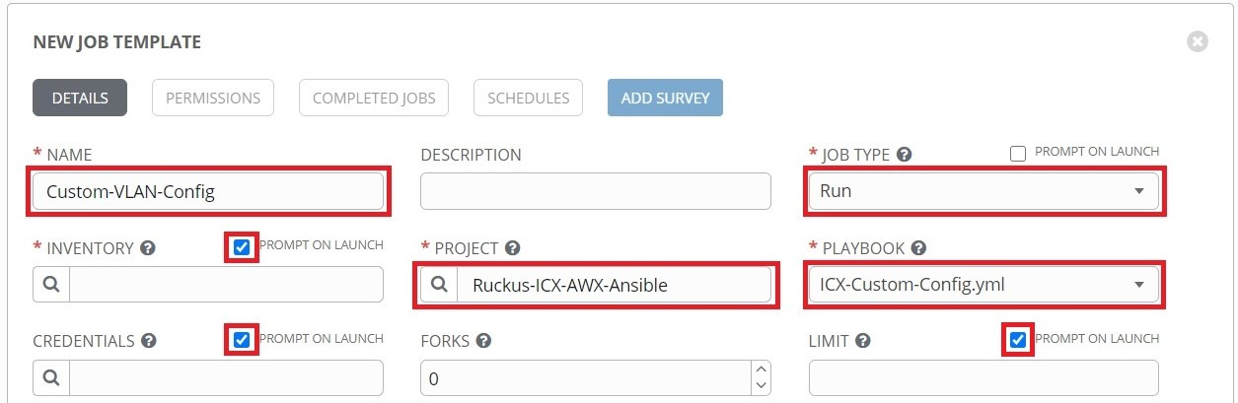

Scroll to the bottom. The switch config will be written as a variable definition in **Extra Variables**:

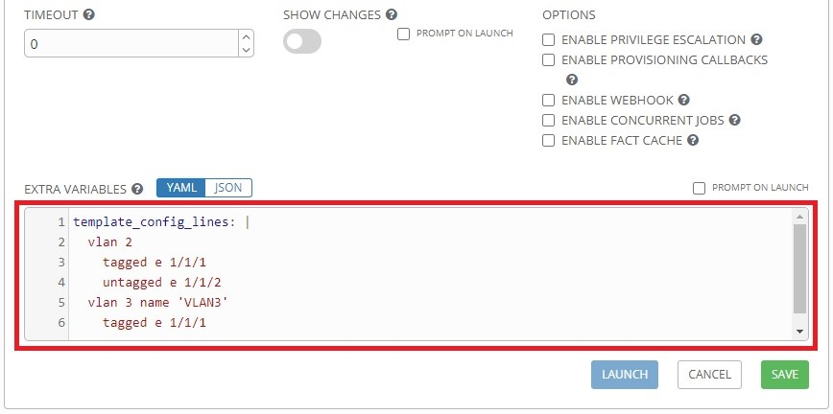

When finished, click **Save**.

Note: The 'ICX-Custom-Config.yml' playbook pushes the configuration that is defined in the '*template_config_lines*' variable to the switch without performing error checking. Custom templates should be tested first before mass deployment.

# 8. Image Management

The Image Management role is included in the 'AWX-Management' project and can utilize AWX to manage the storage and deployment of application and boot-monitor images for the ICX platform. Currently only ICX7XXX series switches are supported.

## 8.1 Image Repository Creation

Before binary images can be imported to the AWX server, a repository will need to be created in the project directory.

Click the **Templates** button from the left navigation bar, then click the launch () button next to "*Image-Management*":

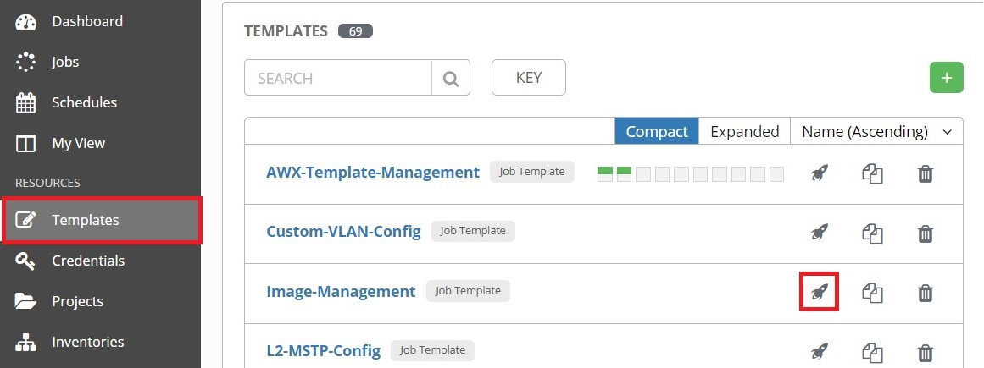

Complete the following field in the Survey Prompt window that appears:

**IMAGE REPOSITORY NAME**: Enter the name of the directory to be created or use the default "*Images*".

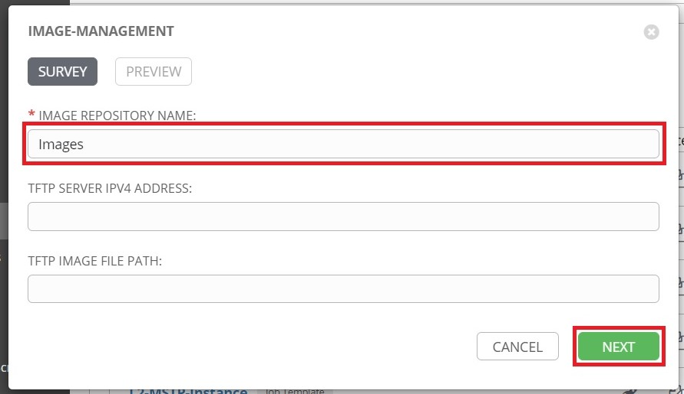

Click **Next** to continue, then click **Launch** on the Preview tab to run the template.

## 8.2 Import images to AWX server

This section details several methods of importing binary images to the AWX server.

Note: Method 1 can only be used if the AWX server has connectivity to the internet to install the TFTPy Python library or if the TFTPy Python library is already installed.

### 8.2.1 (Method 1) TFTP pull from AWX server

A TFTP server can be utilized to copy binary images to the image repository directory.

In the example below, the boot and application images have been copied to the C:\TFTP\ folder:

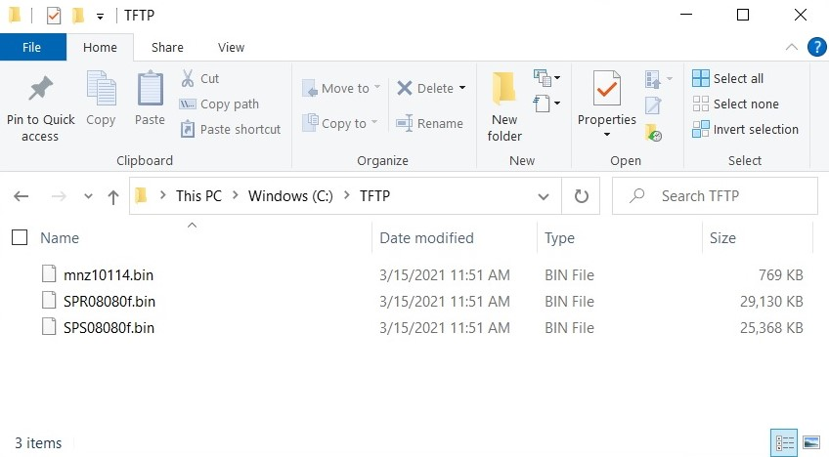

The following example uses tftpd64 as the TFTP server. Ensure the following options are set:

**Current Directory**: Ensure this is pointing to the image directory.

**Server interfaces**: Select the interface the TFTP server will listen on.

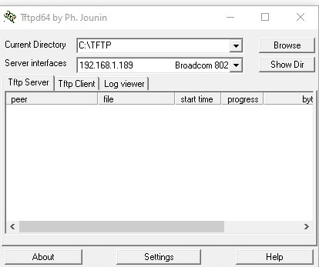

The credentials to SSH into the AWX server will need to be added to the Image-Management template to use the TFTP client. Click the **Templates** button from the left navigation bar, then click "*Image-Management*":

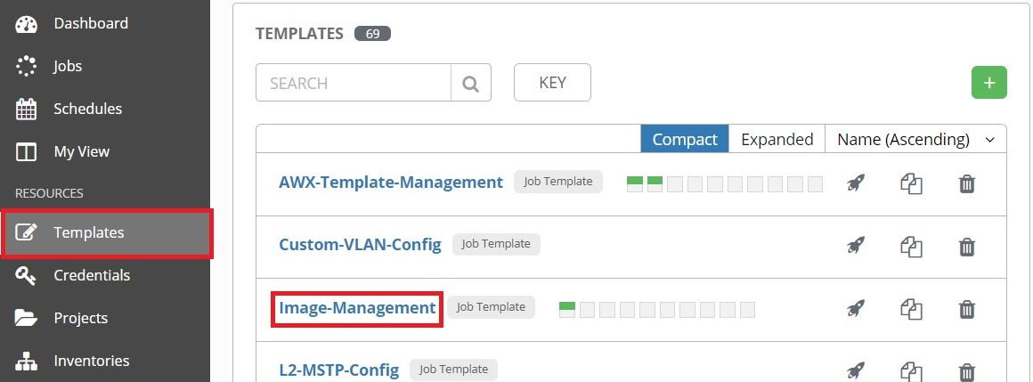

On the "*Image-Management*" template page, click the  button to open the credentials window:

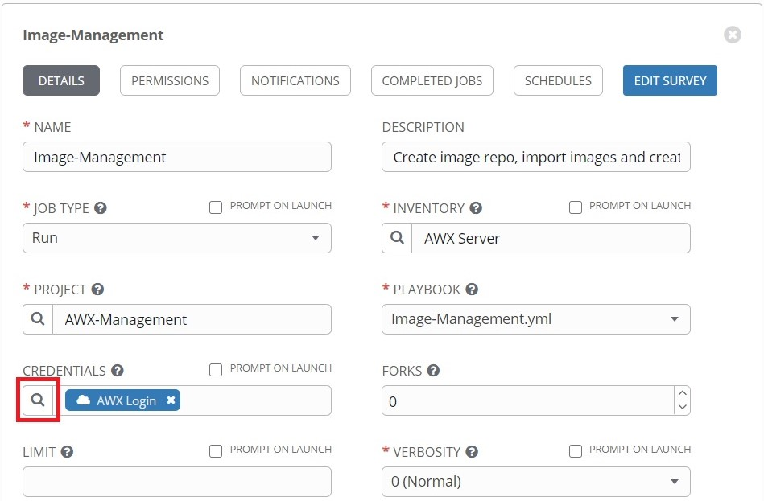

Select the SSH credentials for the AWX server, then click **Select**:

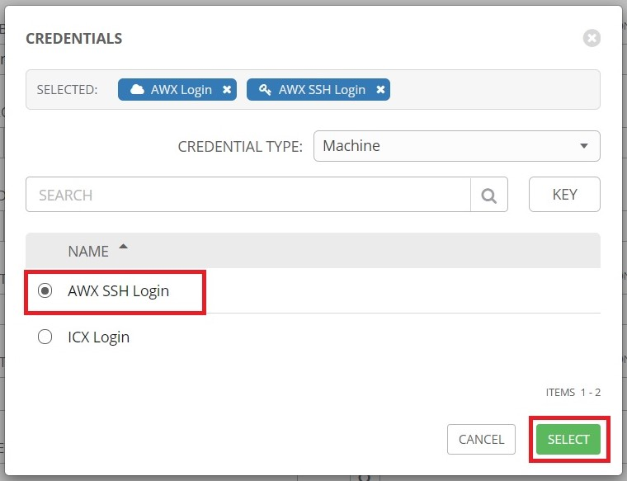

At the bottom of the "*Image-Management*" page, click **Save**:

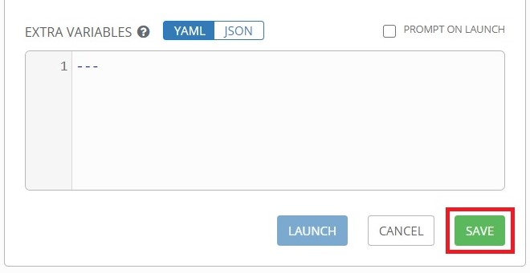

Once the template is saved, click **Launch**:

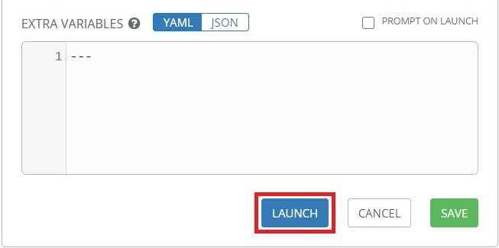

Complete the following fields in the prompt window that opens:

**IMAGE REPOSITORY NAME**: Ensure this matches the name of the image repository.

**TFTP SERVER IPV4 ADDRESS**: Enter the IP address of the TFTP server.

**TFTP IMAGE FILE PATH**: Enter the path to the file to be copied from the TFTP root.

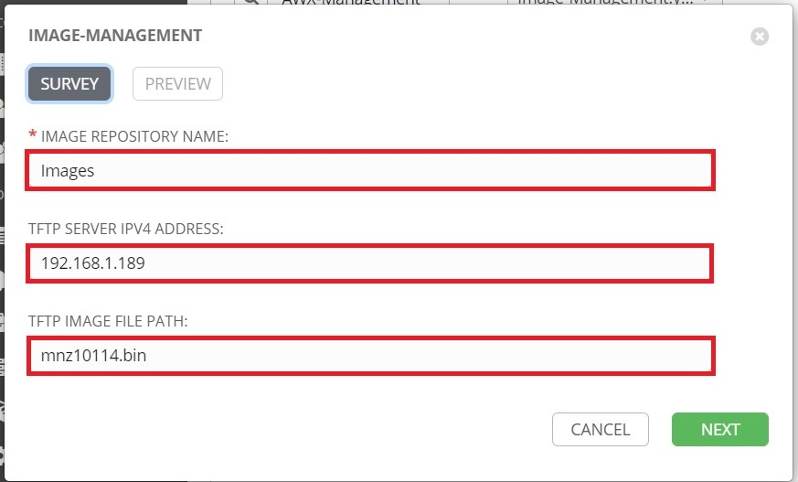

Click **Next** to continue, then click **Launch** on the Preview tab to run the template.

Relaunch the template to copy additional files to the image repository. When finished copying files, close the TFTP server.

### 8.2.2 (Method 2) SCP push to AWX server.

TFTP is an insecure method of transferring files due to a lack of encryption and authentication. It is recommended to use SCP when possible. An additional benefit to using SCP is the ability to transfer multiple files at once. Windows 10 update 1803 includes a native SSH client. Alternatively, the PuTTY suite contains an SCP program: pscp.exe.

To prepare the AWX server to receive the files, first SSH into the server and create a folder that the files will be copied to. In this example, the "*Images*" folder is created in the user's home directory:

|  |
| --- |
| awxuser@awxserver:~$ mkdir -p ~/Documents/Images/  awxuser@awxserver:~$ |

From the Windows workstation, copy the boot and application images to the C:\TFTP\ folder:



From the Windows workstation, open the command prompt and navigate to the directory with the images. The **dir** command can be executed to verify that the files exist:

|  |
| --- |
| C:\Users\Brian.Stepp>cd c:\TFTP  c:\TFTP>dir  Volume in drive C is Windows  Volume Serial Number is CE9D-669D  Directory of c:\TFTP  03/19/2021 10:25 AM <DIR> .  03/19/2021 10:25 AM <DIR> ..  03/15/2021 11:51 AM 786,944 mnz10114.bin  03/15/2021 11:51 AM 29,829,112 SPR08080f.bin  03/15/2021 11:51 AM 25,976,488 SPS08080f.bin  3 File(s) 56,592,544 bytes  2 Dir(s) 15,008,501,760 bytes free |

To copy the files from the workstation to the AWX server, execute the **SCP** command using this syntax:

|  |
| --- |
| scp <source> <username>@<destination_ip>:<destination_path> |

Command breakdown:

* **source:** Local path to the file that is to be copied. *.bin can be used to copy all .bin files.
* **username:** Username used to login to the AWX server.
* **destination_ip:** IP or hostname of the AWX server.
* **destination_path:** Path to the destination directory for the image files.

For example:

|  |
| --- |
| c:\TFTP>scp .\*.bin awxuser@192.168.1.196:/home/awxuser/Documents/Images/  awxuser@192.168.1.196's password:  SPR08080f.bin 100% 28MB 42.2MB/s 00:00  SPS08080f.bin 100% 25MB 43.9MB/s 00:00  mnz10114.bin 100% 769KB 133.6MB/s 00:00  c:\TFTP> |

Once the images have been copied over, SSH into the AWX server and move the image files to the image repo directory using elevated privileges:

|  |
| --- |
| awxuser@awxserver:~$ sudo mv /home/awxuser/Documents/Images/*.bin /var/lib/awx/projects/Images/  [sudo] password for awxuser:  awxuser@awxserver:~$ |

When the files have been moved to the image repo directory, the "*Image-Management*" template will need to be run. Click the **Templates** button from the left navigation bar, then click the launch () button next to "*Image-Management*":

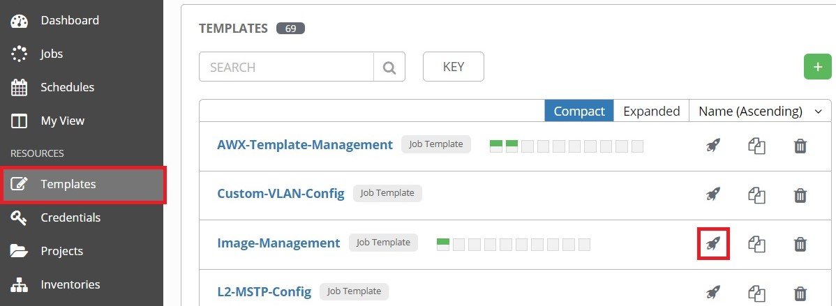

Complete the following field:

**IMAGE REPOSITORY NAME:** Ensure this matches the name of the image repository.

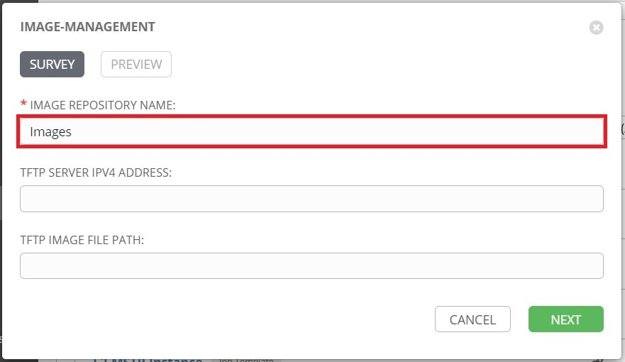

Click **Next** to continue, then click **Launch** on the Preview tab to run the template.

## 8.3 View Image Repository Files

Click the **Inventories** button from the left navigation bar, then click the inventory that contains the AWX server host:

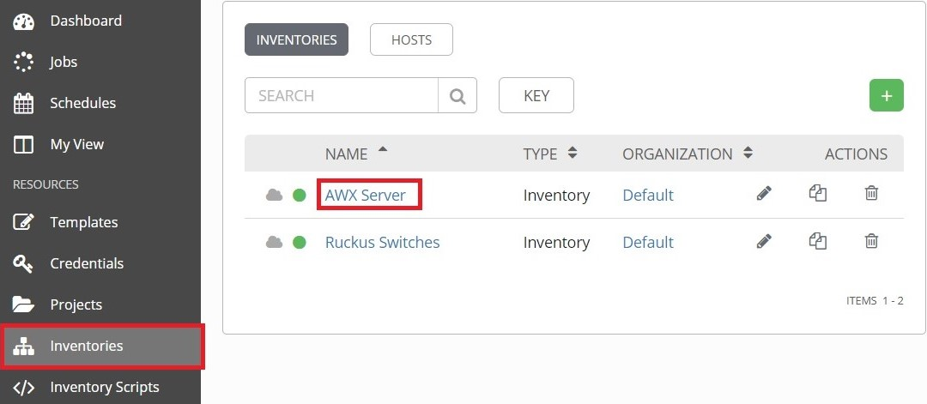

From the AWX server inventory page, click the **Hosts** tab, then click the AWX server host:

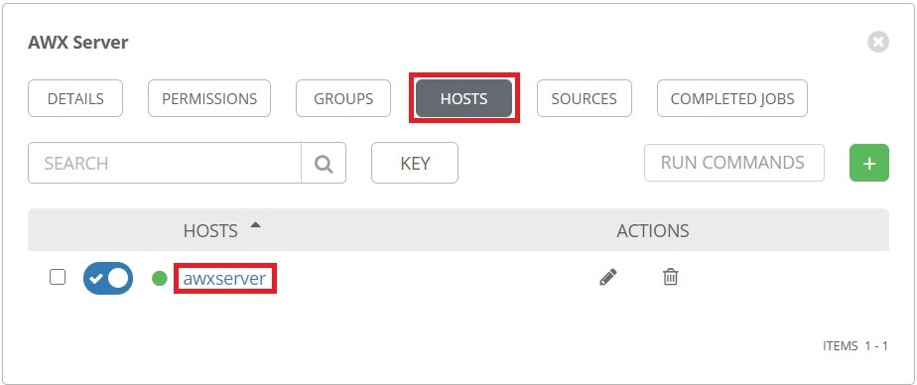

From the AWX server host page, click the **Facts** tab, then click on **Expand**:

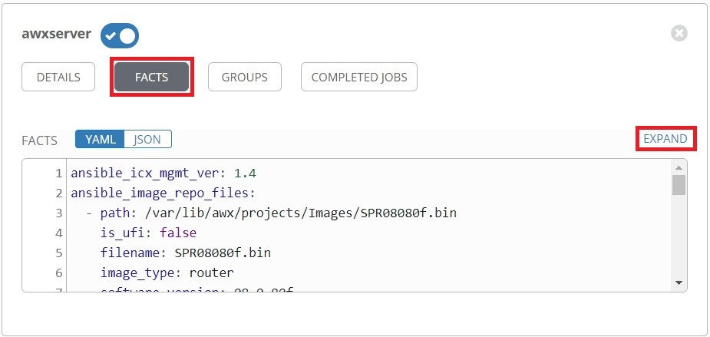

An expanded facts window will appear. The application image files will be listed under the "*ansible_image_repo_files*" variable:

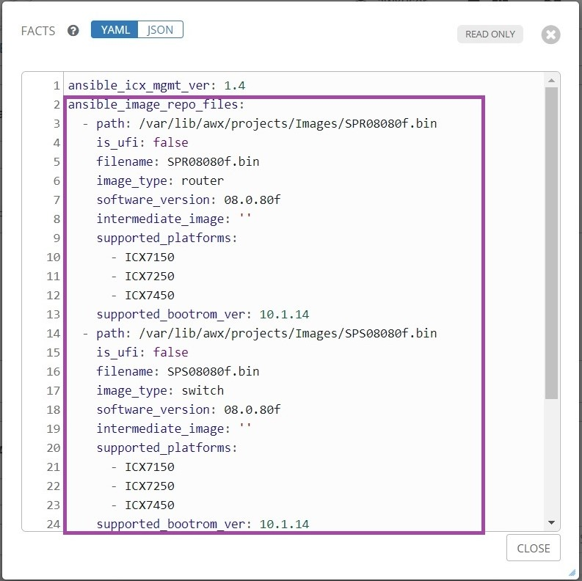

Scroll down to view the boot image files listed under the "*ansible_image_repo_boot_files*" variable:

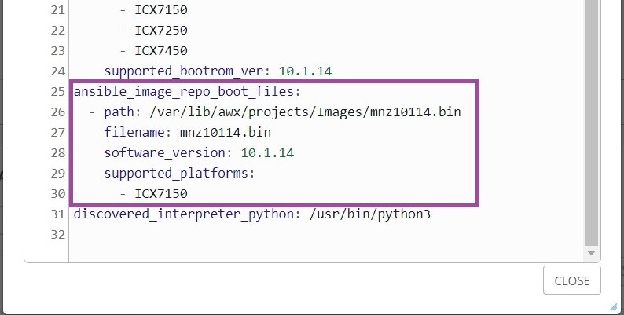

## 8.4 Copy image files to switch flash

Running "*Image-Management*" will create the "*Image-Flash-Copy*" template when valid images exist in the image repository. The survey prompt in the "*Image-Flash-Copy*" template contains a list of valid images and this list is updated every time the "*Image-Management*" template is run.

Note: If the AWX server has internet connectivity, running the "*Image-Management*" template will attempt to install the Pexpect Python module if it does not exist. If the Pexpect module is not able to be installed, the icx_copy module will be utilized to flash images to the switch.

### 8.4.1 Switch image copy (using Pexpect module)

To flash an image to a switch, first click the **Template** button from the left navigation bar, then click the launch () button next to "*Image-Flash-Copy*":

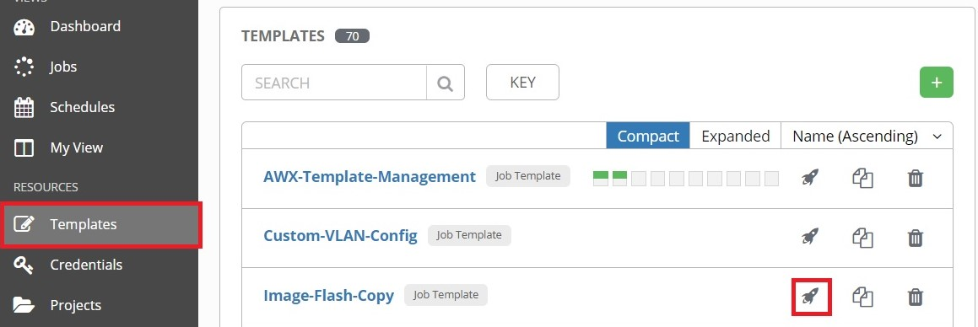

Select the inventory containing the switch hosts, then click **Next**:

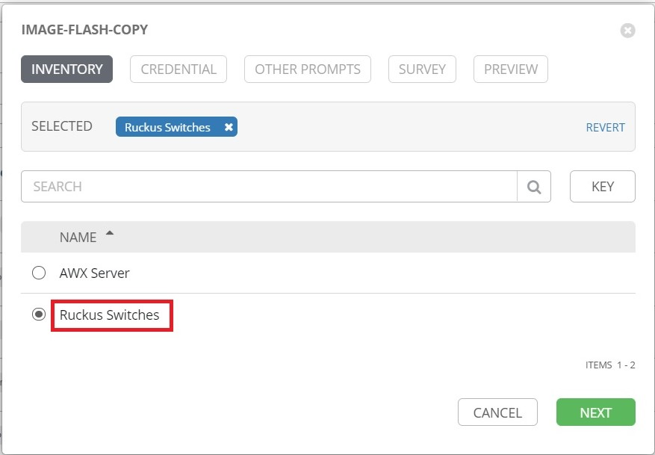

Select the switch login credentials, then click **Next**:

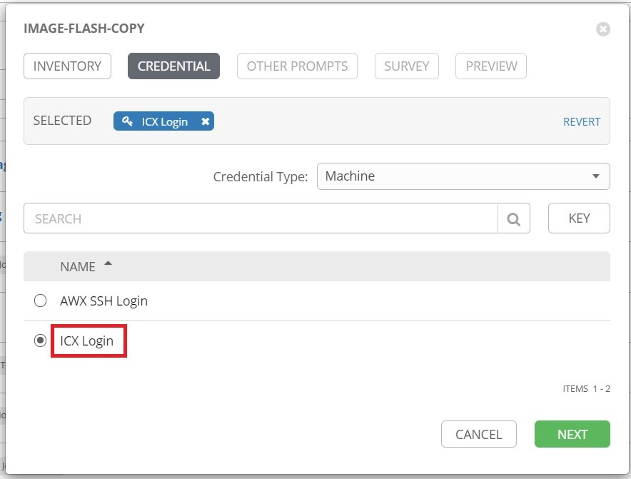

The Limit prompt can limit the execution of the template to a single host in an inventory. If left blank, the template will run against all hosts in the inventory. The host's name can be entered into the prompt to limit execution to that host:

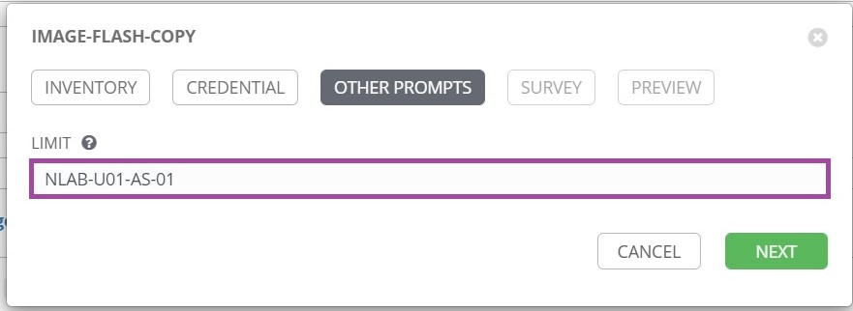

Click **Next** to continue.

In the Survey prompt, complete the following fields:

**SELECT THE IMAGE FILE TO FLASH**: Select the application image from the drop-down menu.

**FLASH PARTITION**: Select the partition on the switch to copy the image to.

**CONFIGURE SELECTED FLASH PARTITION AS FIRST IN BOOT ORDER**: Select **Yes** to ensure selected flash partition has priority during boot.

**SELECT BOOT IMAGE TO FLASH**: Selecting **Auto Select** will attempt to match the targeted switch model and application version to an installed boot image. Select **None** to skip copying of boot image. Select a boot image from the list to attempt to force installation of that boot image.

**REBOOT INTO NEW IMAGE AFTER DEPLOYMENT**: Select **Yes** to perform a boot into the selected boot partition of the switch after the image(s) have been copied.

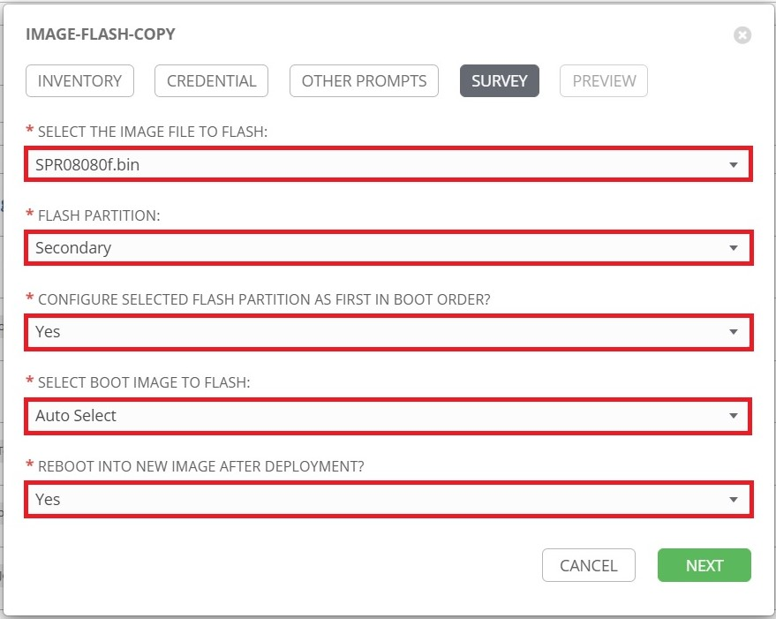

When finished, click **Next**, then click **Launch** on the Preview tab to run the template.

### 8.4.2 Switch image copy (using icx_copy module)

To flash an image to a switch, first click the **Template** button from the left navigation bar, then click the launch () button next to "*Image-Flash-Copy*":



Select the inventory containing the switch hosts, then click **Next**:



Select the switch login credentials, then click **Next**:



The Limit prompt can limit the execution of the template to a single host in an inventory. If left blank, the template will run against all hosts in the inventory. The host's name can be entered into the prompt to limit execution to that host:



Click **Next** to continue.

In the Survey prompt, complete the following fields:

**SELECT THE IMAGE FILE TO FLASH**: Select the application image from the drop-down menu.

**FLASH PARTITION**: Select the partition on the switch to copy the image to.

**CONFIGURE SELECTED FLASH PARTITION AS FIRST IN BOOT ORDER**: Select **Yes** to ensure selected flash partition has priority during boot.

**SELECT BOOT IMAGE TO FLASH**: Selecting **Auto Select** will attempt to match the targeted switch model and application version to an installed boot image. Select **None** to skip copying of boot image. Select a boot image from the list to attempt to force installation of that boot image.

**REBOOT INTO NEW IMAGE AFTER DEPLOYMENT**: Select **Yes** to perform a boot into the selected boot partition of the switch after the image(s) have been copied.

**AWX SERVER SSH LOGIN – USERNAME:** Username for CLI access to AWX server.

**AWX SERVER SSH LOGIN – PASSWORD:** Password for CLI access to AWX server.

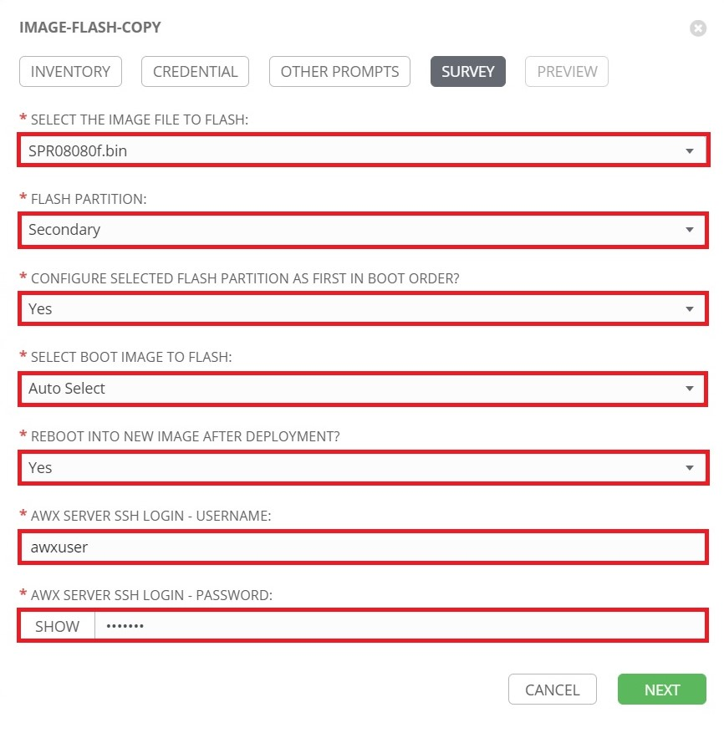

When finished, click **Next**, then click **Launch** on the Preview tab to run the template.

# 9. Setup AWX-ZTP

Zero-Touch Provisioning (ZTP) is a feature that allows for automatic provisioning and configuration of network devices when they come online. The 'AWX-ZTP' project utilizes AWX to provide zero-touch provisioning of Ruckus ICX switches.

## 9.1 Create 'ZTP-Install' Template

Click the **Templates** button from the left navigation bar. Then click the launch () button next to **AWX-Template-Management**:

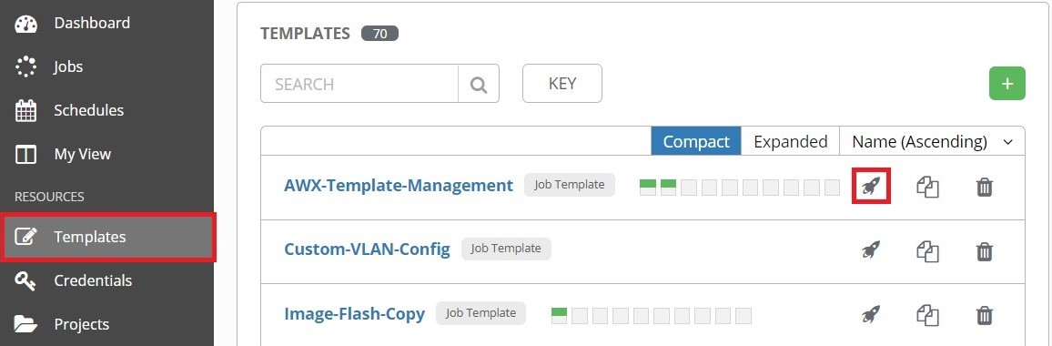

Complete the following fields in the Survey Prompt window that appears:

**TEMPLATE MANAGEMENT FUNCTION:** Select **Create/Update Templates**.

**PROJECT:** Select **AWX-ZTP**.

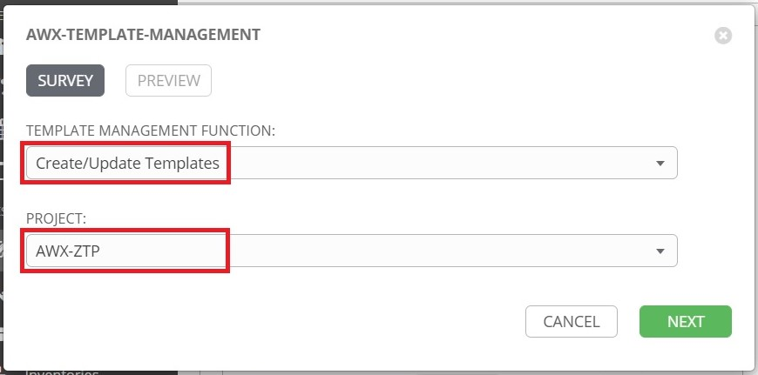

Click **Next** when finished, then click **Launch**. The "*ZTP-Install*" template will appear in the "*AWX-ZTP*" project upon completion.

## 9.2 Launch "ZTP-Install"

The "*ZTP-Install*" template installs several components necessary for ZTP.

Click **Projects** from the left navigation bar, then click on the "*AWX-ZTP*" project:

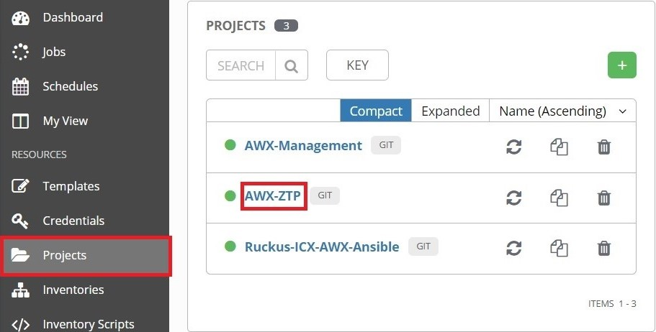

Click the **JOB TEMPLATES** tab, then click the Launch () button next to "*ZTP-Install*":

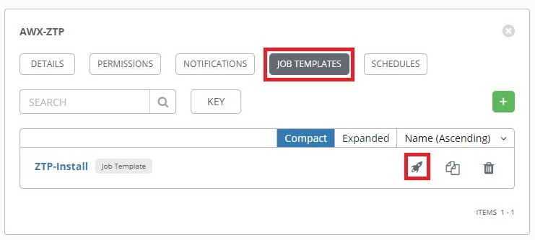

Select the inventory that holds the AWX Server as a host, then click **Next**:

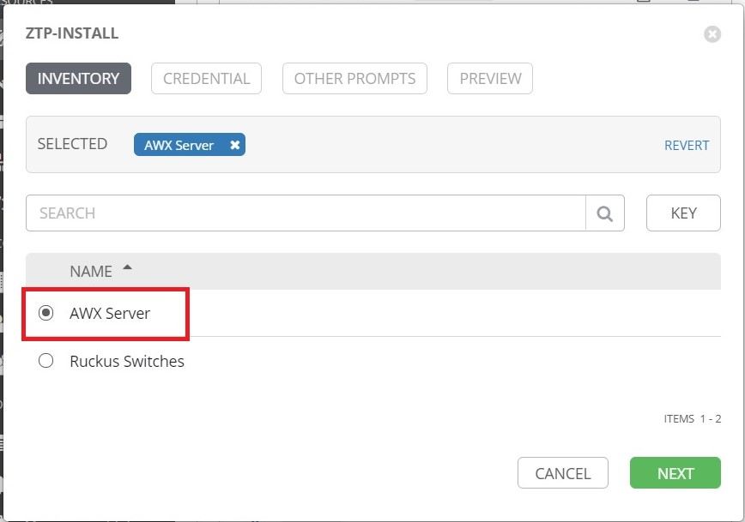

On the **CREDENTIAL** tab, two sets of credentials will need to be selected, one for the SSH Login to the AWX server and one for the REST API credentials. First select the AWX SSH Login credentials, then open the drop-down menu for **Credential Type**:

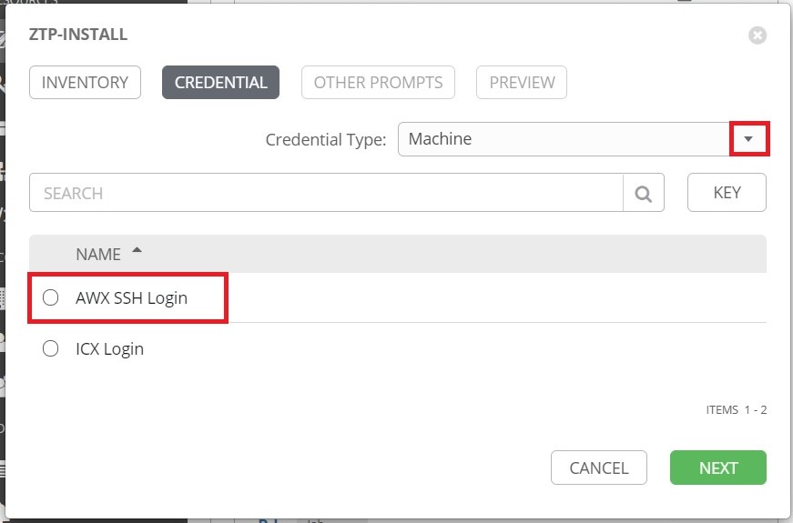

Select **AWX REST API** from the drop-down menu:

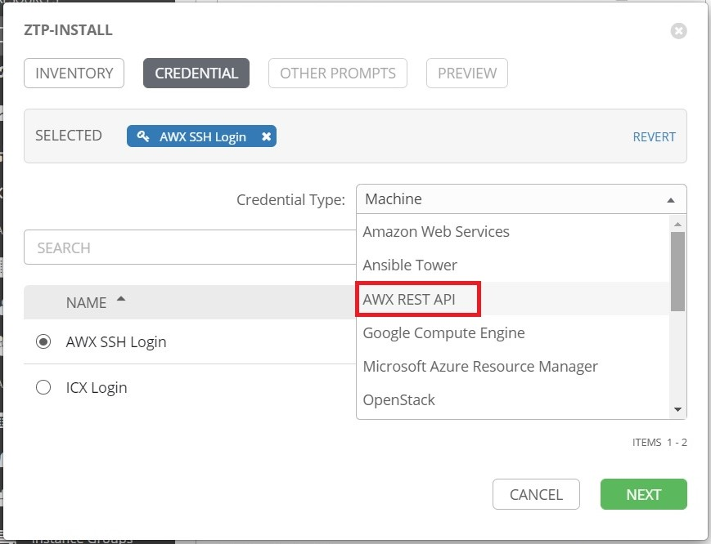

Select the credentials for the AWX REST API:

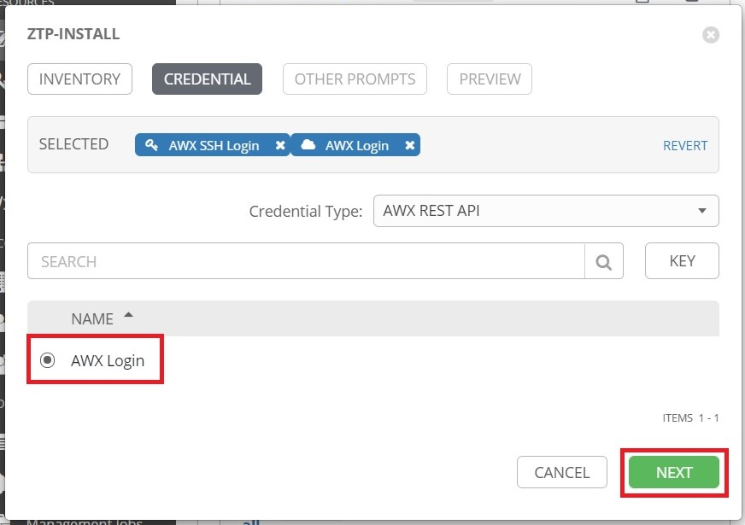

The **Limit** prompt can be left blank. Click **Next**:

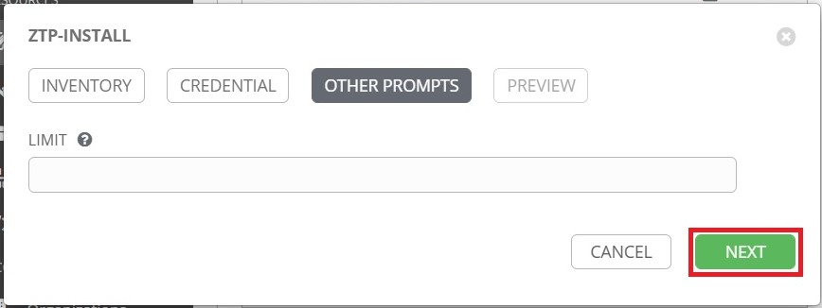

Click the **Launch** button to start the ZTP install:

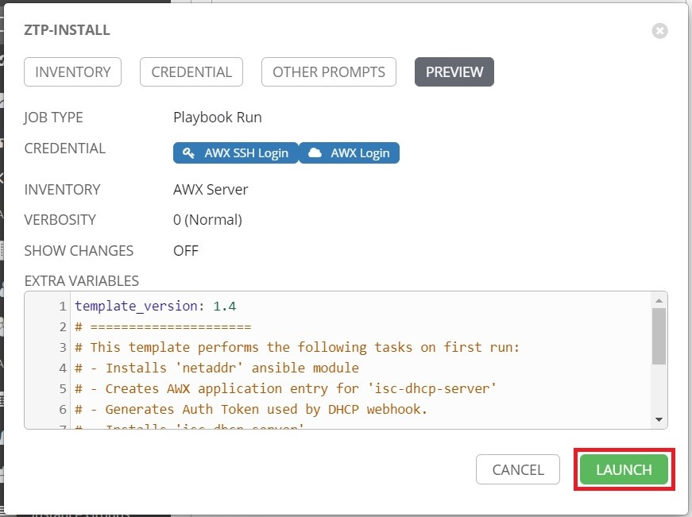

In addition to installing necessary components for ZTP, the "*ZTP-Install*" template also creates two additional templates: "*ZTP-Configure*" and "*ZTP-Regen-AuthToken*". The "*ZTP-Regen-AuthToken*" template can be run to regenerate the AWX Application Authentication Token used by the DHCP webhook script.

## 9.3 Launch "ZTP-Configure"

The "*ZTP-Configure*" template can perform several tasks including:

Configures a secondary interface on the AWX server with an IP address.

Creates a provisioning inventory in AWX. Hosts discovered by DHCP are placed here.

Configures DHCP on the AWX server.

Creates an IP pool for configuring a static IP address on a host interface.

Creates a hostname pool to configure a hostname on a host.

The following provides a guide for running the "*ZTP-Configure*" template.

Click **Projects** from the left navigation bar, then click on the "*AWX-ZTP*" project:



Click the **JOB TEMPLATES** tab, then click the Launch () button next to "*ZTP-Configure*":

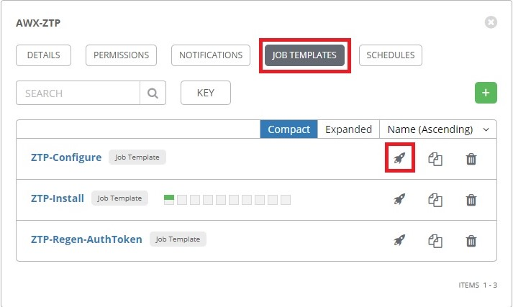

Complete the following fields:

**PROVISIONING INVENTORY:** Name of ZTP Inventory to create.

**SELECT ZTP INTERFACE:** Select the interface configure a static IP address on.

**INTERFACE IP ADDRESS AND MASK:** Enter the IP address and mask to statically assign to the interface.

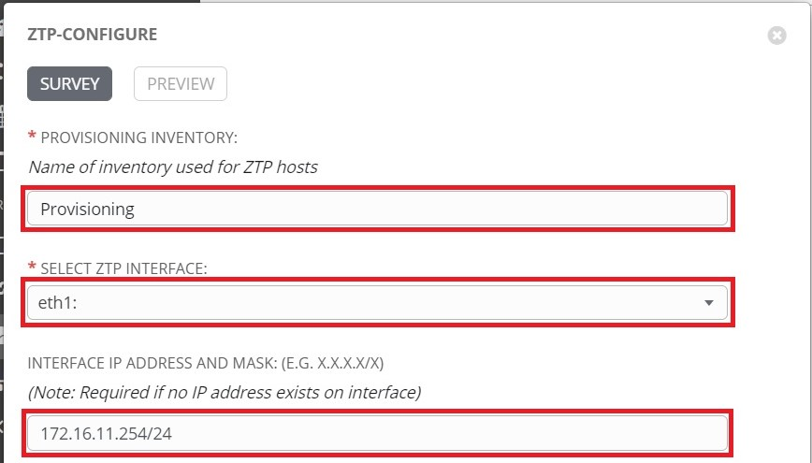

Scroll down to complete the DHCP config fields:

**DHCP SUBNET IP AND MASK:** Enter the DHCP subnet prefix and mask.

**DHCP SUBNET RANGE:** Enter the IP range to be used as the DHCP allocation pool.

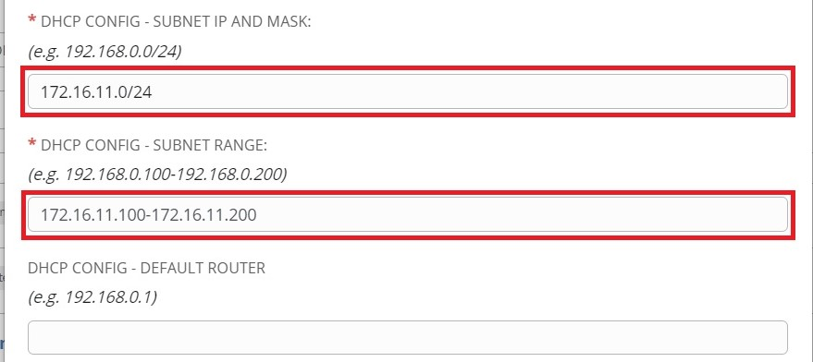

Scroll down to complete the remaining fields.

**STATIC IP POOL SWITCH INTERFACE:**  Interface on switch where static IP will be configured.

**STATIC IP POOL SUBNET:** Enter the prefix and mask of static IP pool network.

**STATIC IP POOL RANGE:** Enter the IP range to be used to allocate static IP addresses.

**HOSTNAME POOL BASE NAME:** Enter the base name to be used for hostname allocation.

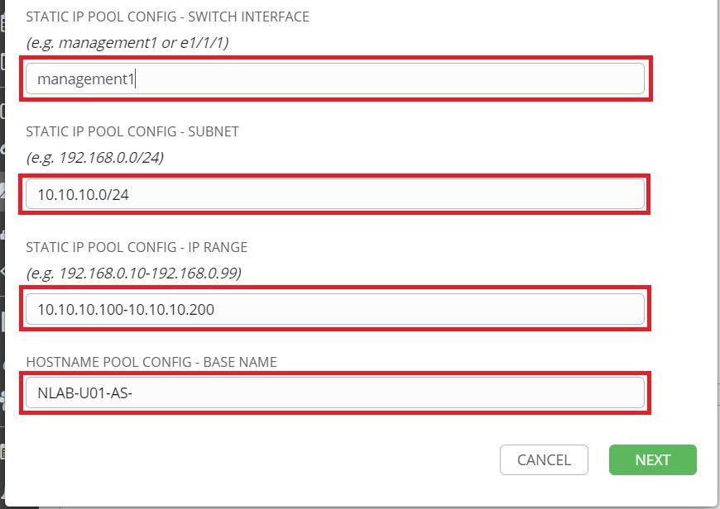

Click **Next** when finished.

Click **Launch**:

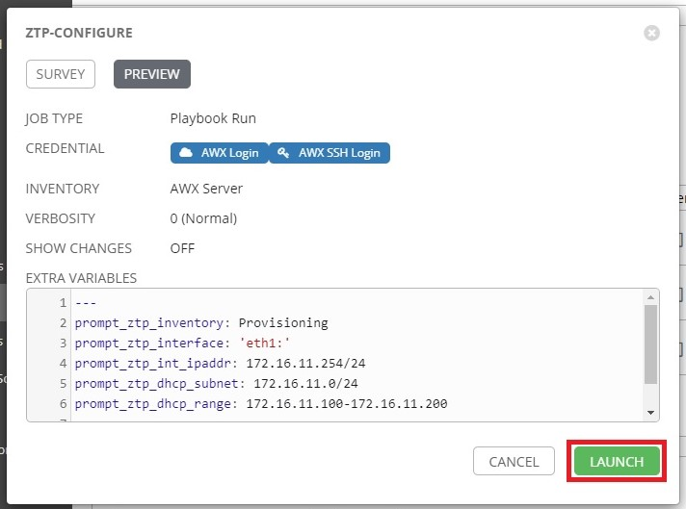

When the template has successfully completed, the DHCP server will begin listening for hosts.

Note:

* The 'Provisioning-Finalize' template handles the assignment of static IP addresses from the pool as well as the assignment of hostnames.
* If the **Static IP Pool Interface** is left blank with the rest of the static IP pool configuration defined, the 'Provisioning-Finalize' template will replace the IP address on the interface that received a DHCP address with an address from the static IP pool.

## 9.4 Workflow Creation

A workflow created in AWX can be automatically launched by the "*Provisioning-Init-Login*" template. The following provides an example of creating a workflow.

Click **Templates** from the left navigation bar. Then click the **+** button and select **Workflow Template**:

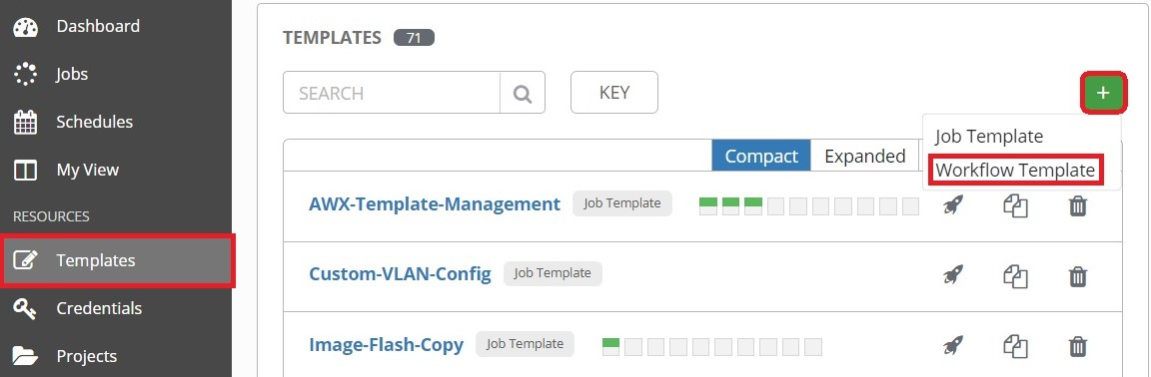

**NAME:** Type in a name for the workflow.

**LIMIT:** Click the checkbox next to **Prompt On Launch.** This is necessary to run the workflow against a single host.

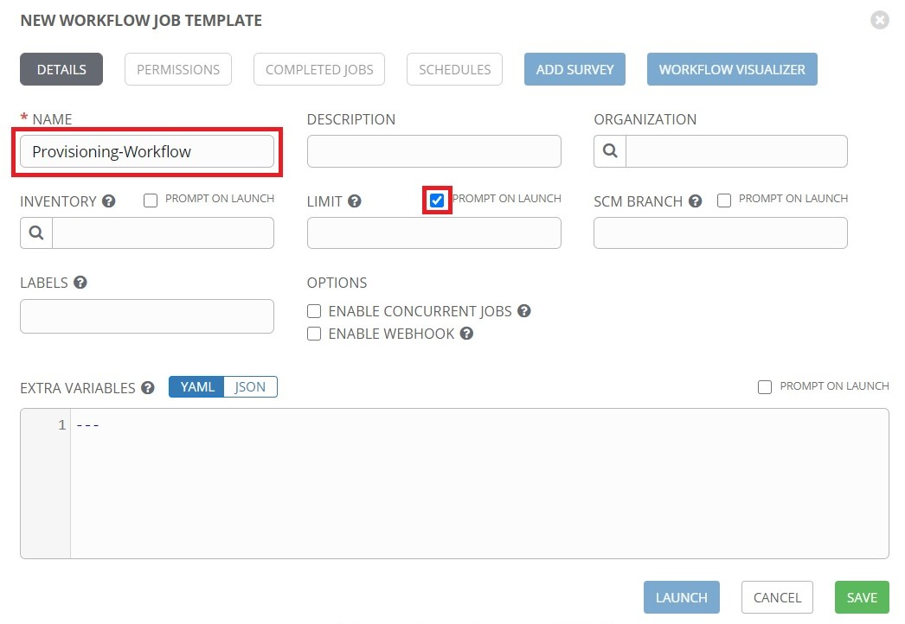

When finished, click **Save**.

The **Workflow Visualizer** will open. Click the **Start** button:

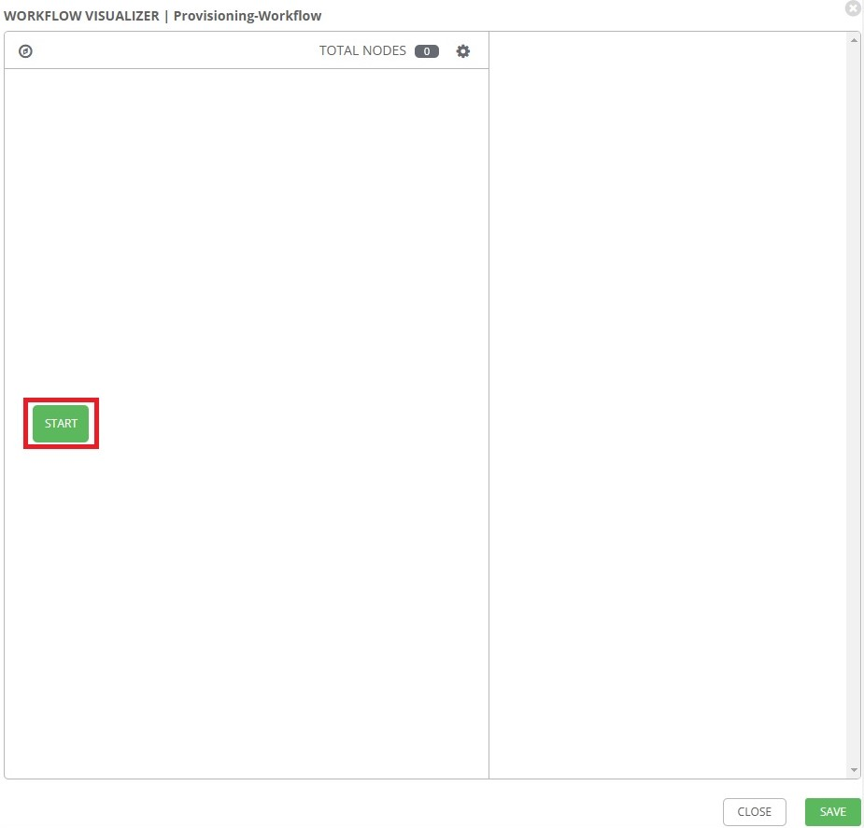

The list of templates will appear on the right. The templates can be added to a workflow here. For this example, click on the **Remote-User-LocalAcct** template, then click **Prompt**:

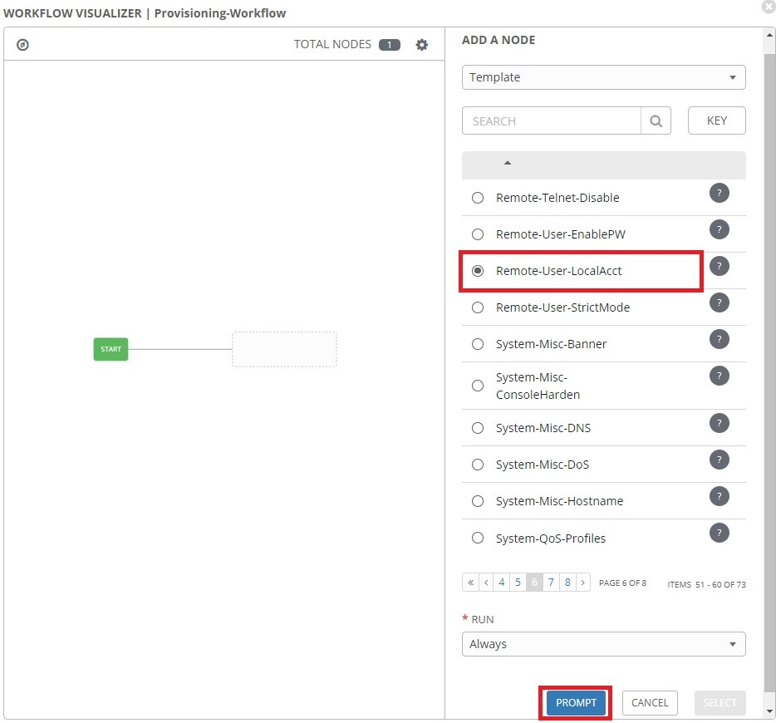

Select the name of the provisioning inventory, then click **Next**:

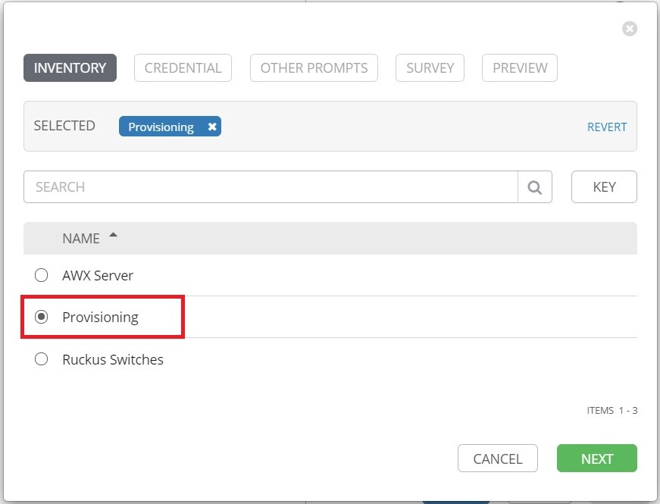

Select the **ZTP_Default_Login** credentials, then click **Next**:

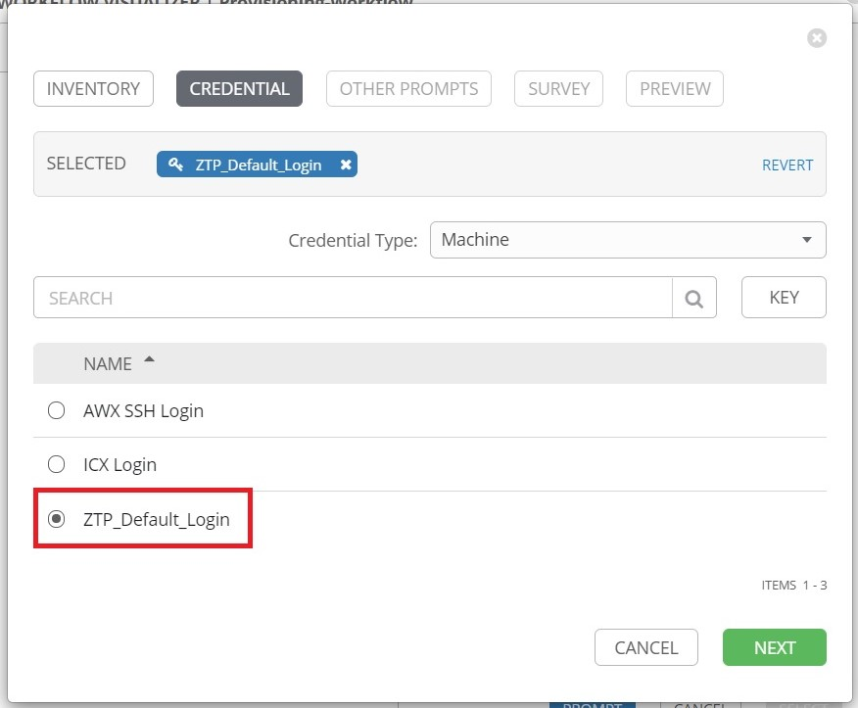

Click **Next**:

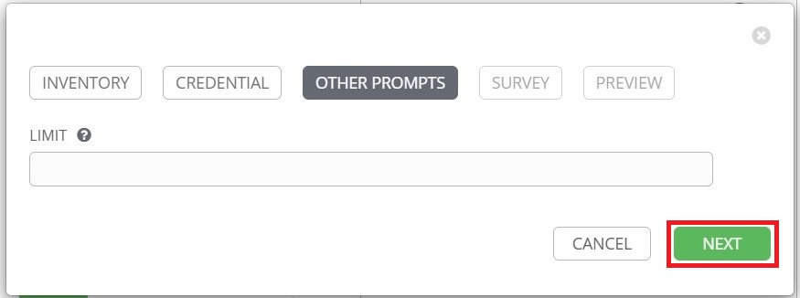

Type in a username and password to add as a local account on the switch:

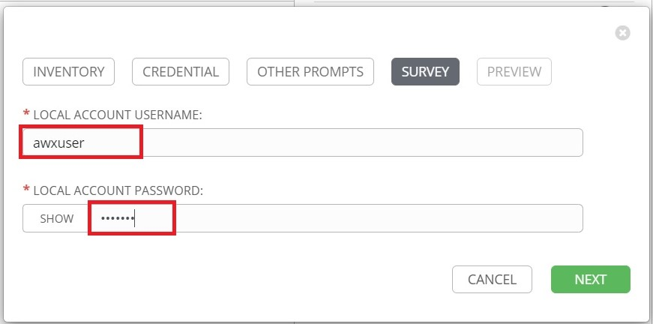

When finished, click **Next.**

Click **Confirm**:

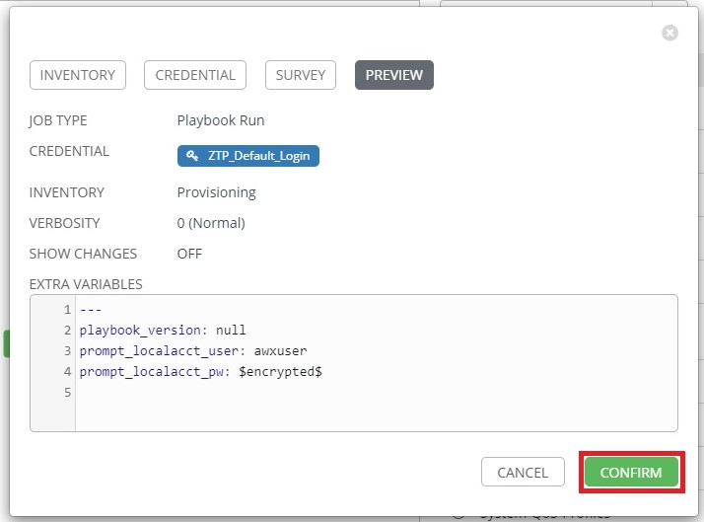

Click **Select** to add the job to the workflow:

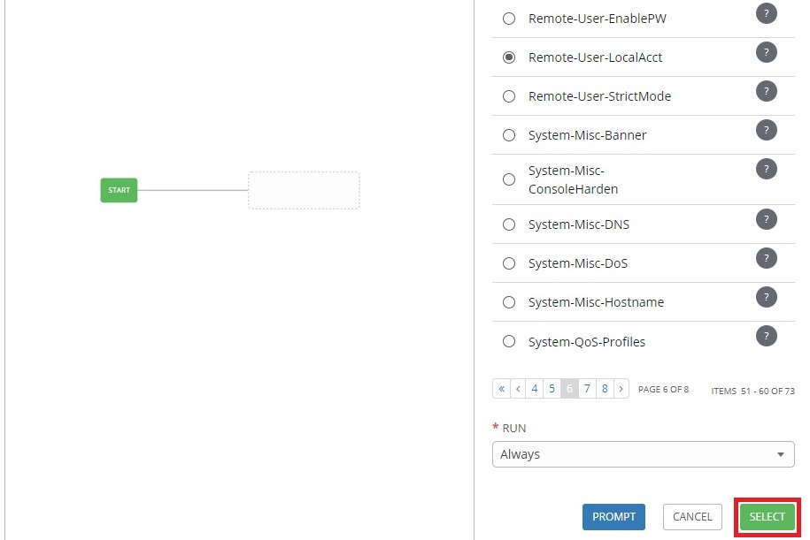

Click the  button to add a node:

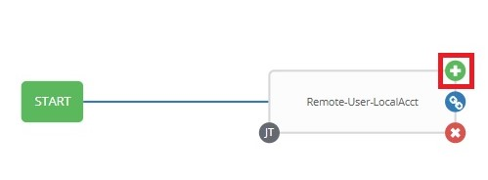

Select another template then click prompt. For this example, the "*L2-VLAN-Config*" is selected:

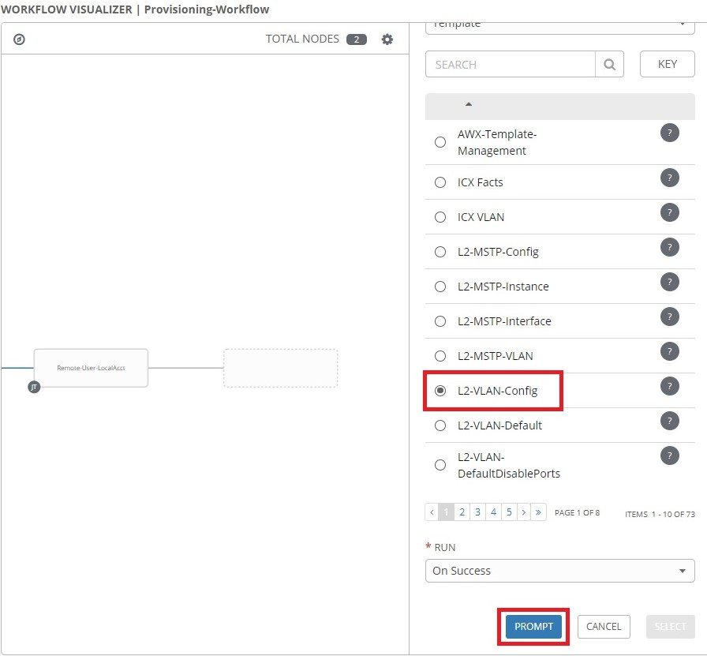

Select the name of the provisioning inventory, then click **Next**:



If the login credentials configured for the job in the previous step match the credentials that are saved in AWX, they can now be selected:

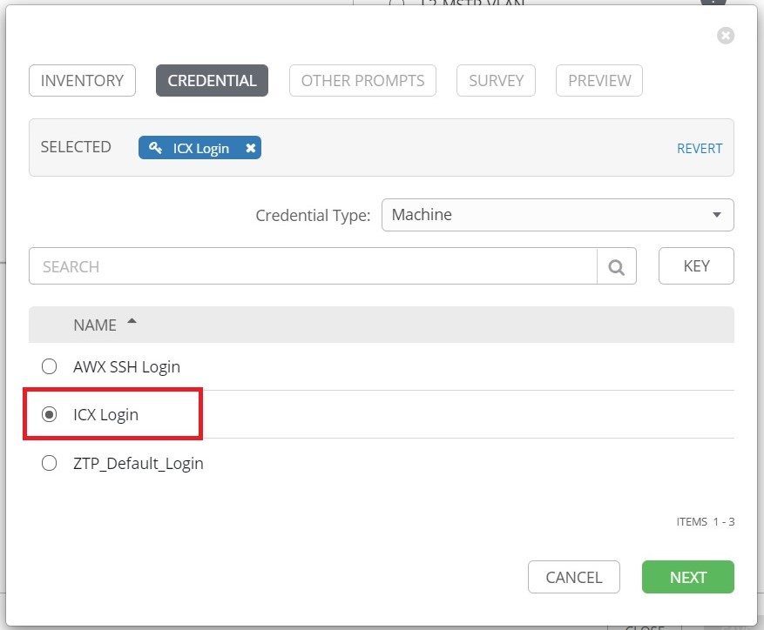

Click **Next** when finished.

Click **Next**:



Complete the Survey prompt on the next page, then click **Next.** In this example, a VLAN named "*Workstation*" with an ID of 301 will be created and ports 1/2/1 and 1/2/2 will be tagged:

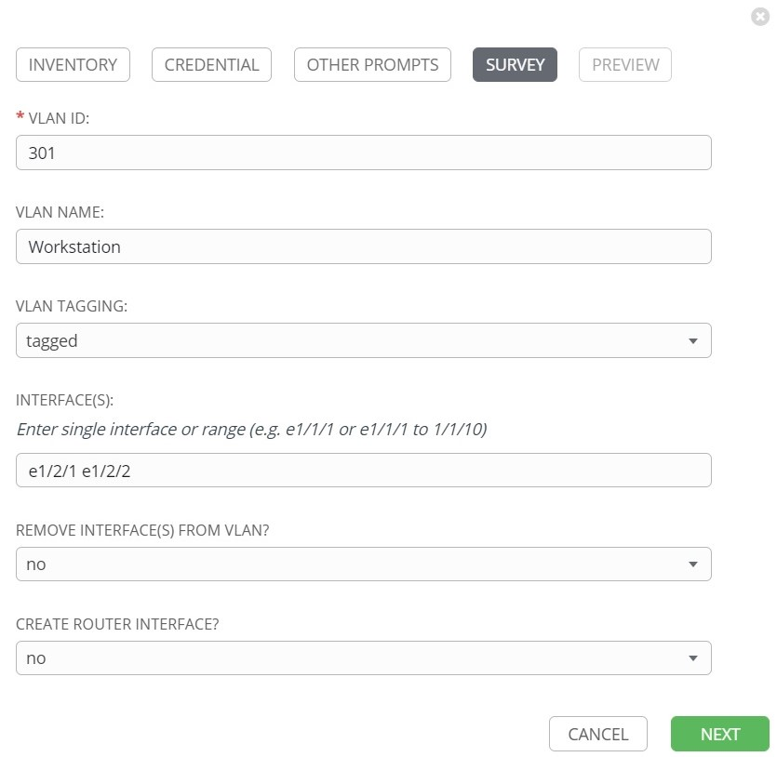

Click **Confirm** on the next window to close the prompt window.

Click **Select** to add the job to the workflow:

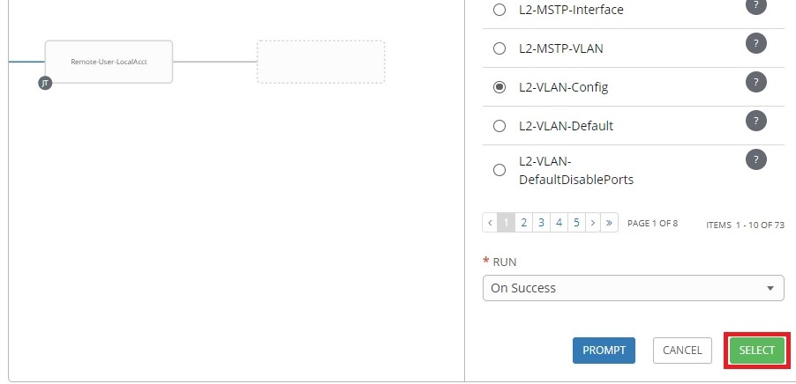

Other templates can be added to the workflow to build out a baseline configuration. Other workflows can also be added to a workflow. The last template to add to the provisioning workflow should be the "*Provisioning-Finalize*" template. This template will configure a static IP address and hostname onto the switch.

To add the "*Provisioning-Finalize*" template to the workflow, click the  button:

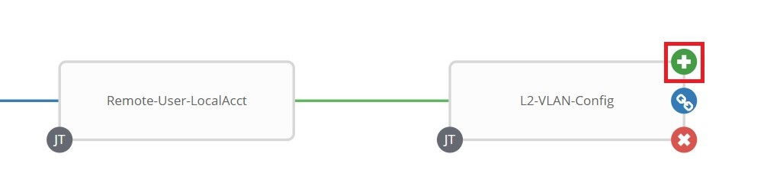

Select "*Provisioning-Finalize*" from the list of templates on the right:

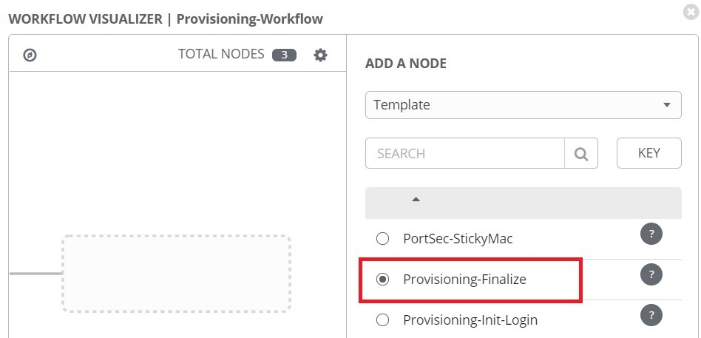

Click **Prompt** at the bottom of the template list:

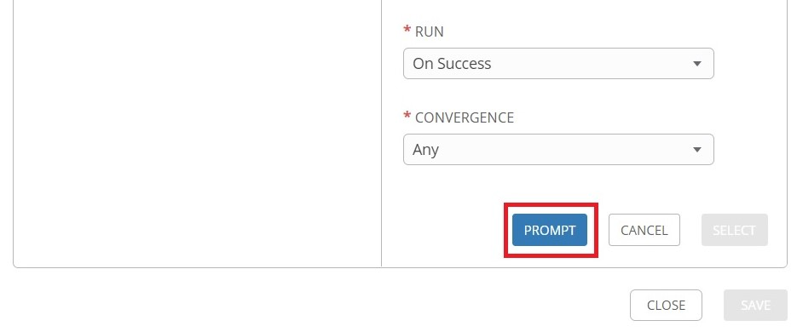

Select the name of the provisioning inventory, then click **Next**:

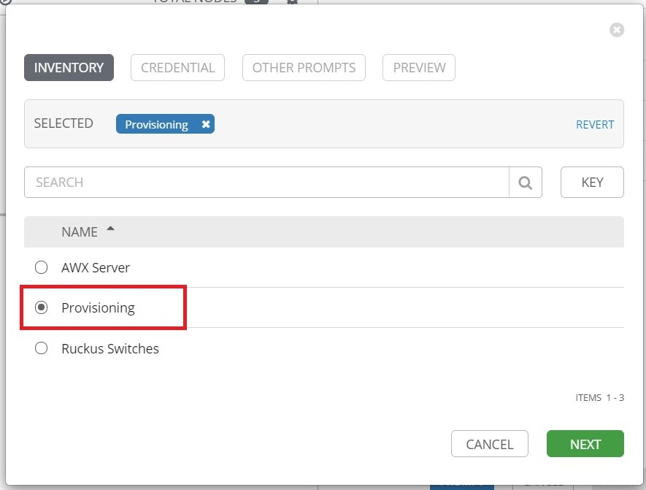

The "*Provisioning-Finalize*" template requires two set of credentials, the switch login credentials and the REST API credentials. First select the credentials used for switch login, then click the drop-down menu for **Credential Type**:

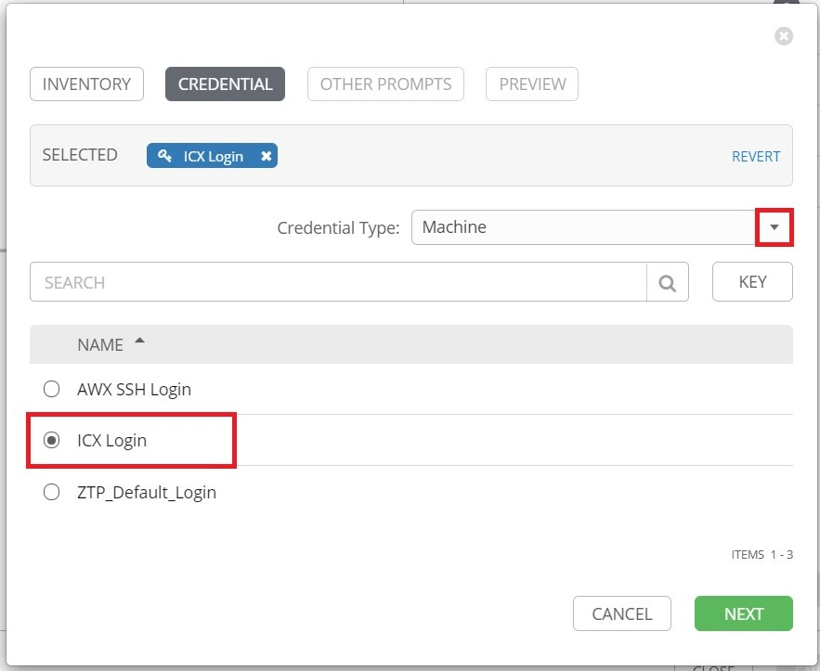

Select **AWX REST API** from the drop-down menu:

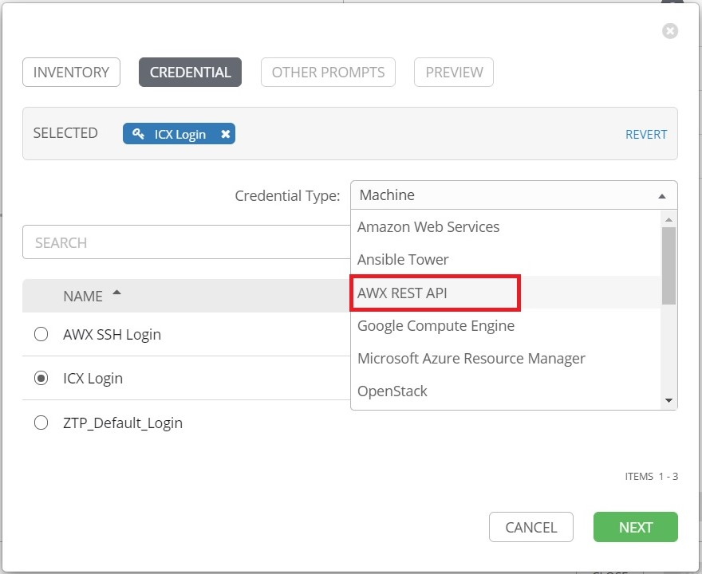

Select the credentials for the AWX REST API, then click **Next**:

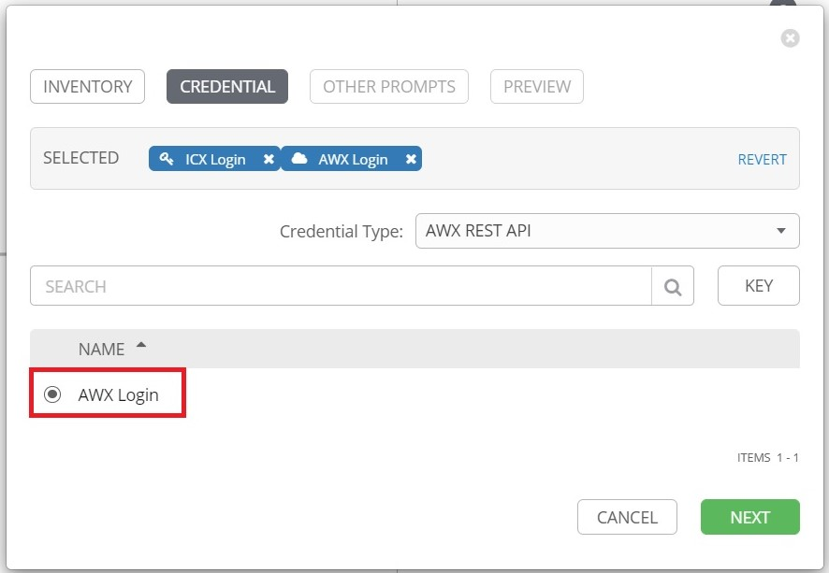

Click **Next** on the Other Prompts page, then click **Confirm** on the Preview page.

Click **Select** to add the job to the workflow:

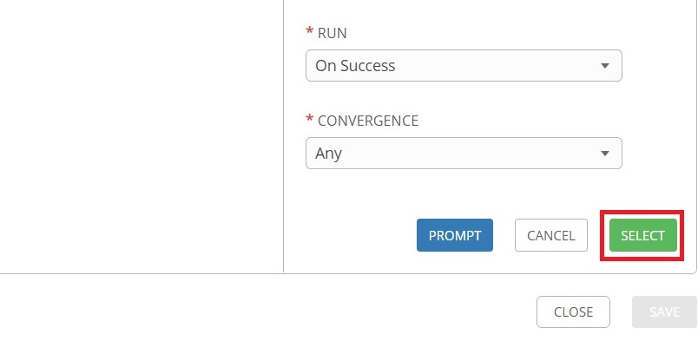

Click **Save** to save the workflow:

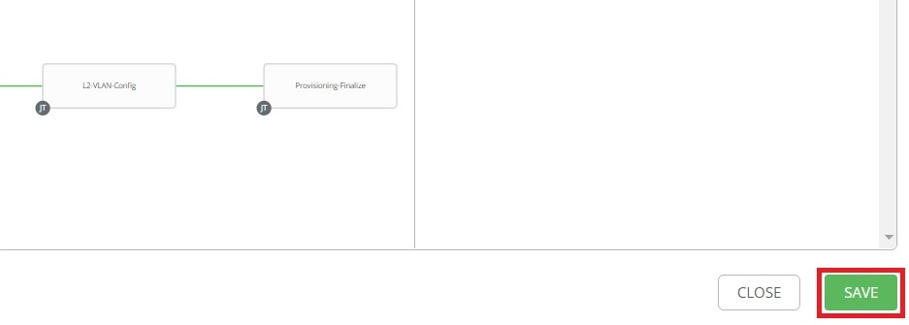

## 9.5 Adding Workflow to ZTP

Now that the workflow is created, it can be added to ZTP.

Click **Inventories** from the left navigation bar, the select the provisioning inventory:

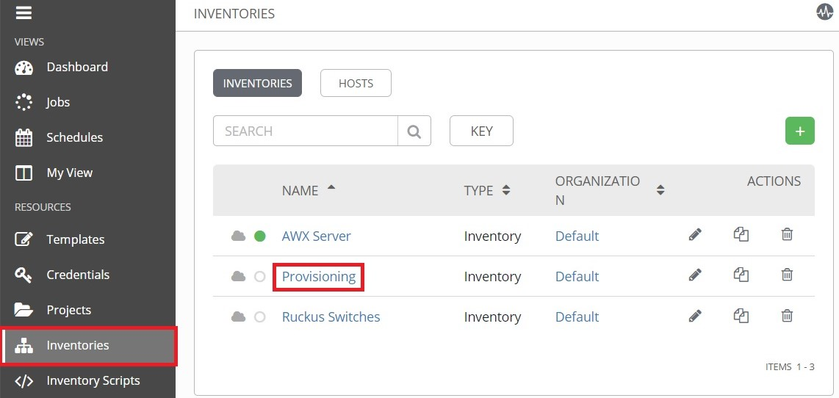

Find the inventory variable named "*icx_inv_ztp_vars.provisioning_vars.workflow*" and define it with the name of the workflow as shown below, then click **Save**:

